A PME exercise with Keystone:

Defining the concept of self reliance; participant evaluation of programme activities related to innovation and self reliance; and food diversity

Background

Keystone has been a partner of the SDC/IC NGO programme since 2000, and has worked in a total 14 tribal villages using programme funds for sustainable land development. In the current consolidation phase, it is focusing on five villages in Kotagiri taluk (plus two in Conoor taluk) – promoting a variety of activities to foster self-reliance and self identity of tribal peoples, through continuing to exert a claim on, and developing, their traditional lands for both food and commercial crops.

When Keystone began activities in the villages, it conducted PRA exercises to assess the existing natural resources, and hence plan activities. Thus for each of the 14 villages, there exists a
- large PRA resource map, on which forest collection areas for NTFPs have subsequently been drawn, plus
- (for five villages only) a participatory transit walk record.
We discussed how these might be used in a participatory review exercise, concluding that a comparison of “then and now” for the transit walk would be interesting. However, this was left for later follow-up as it would require prior organization, and at least two days to complete.

Before the exercise recorded here, Keystone began a participatory evaluation, noting that it is too late to do monitoring as such now. Staff decided the five main aspects that they needed to evaluate were:
- Did the project lead to self reliance?
- Did the project have participation?
- Did the project increase crop diversity?
- Did the project prevent soil and water erosion?
- Does the project have elements of innovation?
In addressing these questions, they used matrix ranking exercises in four villages, finding that some participants could relate to this much more quickly than others. In a number of cases, it was impossible to reach group consensus, so individuals ranked criteria separately. The criteria used were largely pre-defined by staff members, who listed out the activities that had been funded through the project.

Method

We conducted the exercise described here in one village, Samaigudal. In reviewing the method used so far, we discussed how the degree of participation might be further enhanced to bring out tribal people’s own perceptions. We decided that the concept of “self reliance” would be worth fully discussing before any ranking exercise took place. The following steps were planned:
- Group discussion of “self reliance”, followed by a ranking of the different criteria
- Use of H form to investigate whether the programme is perceived to have produced innovations – and if so, what
- Investigation of any changes in food consumption patterns using a matrix to compare “before 2001” and “after 2001 – ie. now”.

The number of villagers attending the meeting, at 30, was quite high – however, the majority of participants were men, women numbering only six. We divided the participants into one men’s and one women’s group.

Defining and ranking attributes of self reliance
Keystone staff belonging to the tribal community took a lead in facilitating this discussion, in a mixture of Tamil and the local tribal language. Every participant took turns to express his/her ideas. A sample – reflecting an influence of age and gender on personal priorities - is given below.

“I can’t go for coolie labour and I don’t want to either. I want enough land to grow maize, millet, coffee and beans…I don’t want to go for coolie labour” (older woman)

“If we have a fund in a group so that we can take it for any purpose and give it back afterwards, that will make us independent” (younger woman)

“One cow is enough…. I am an old man, too old to work on the land. If I have a cow and can sell milk to others in the community, that is enough.” (older man)

“We are basket weavers – we want to make something useful to sell so that we can live from the proceeds” (younger man).

After this, all the suggested criteria for self reliance were listed out (using pictorial symbols rather than words), and each group (men and women) were asked to score them using beans. Keystone provided large kidney beans for this purpose; it was suggested that each attribute could have a maximum score of ten beans (and a minimum of zero). The men managed to discuss this in a group and reach a consensus; the women found it easier to give their own ideas separately. Their individual scoring was then converted into an average.

Careful facilitation of this discussion was necessary to ensure that participants did not turn it into a “wish list” of activities that they would like to do in future.

Results of discussions on self reliance

The attributes of self reliance that the community members defined are given in the box below, together with the scores/ranking obtained.

Box 1: Attributes of self reliance and their relative importance to Samaigudal community members
Women Men
Growing cash crops on own land 57 (1) (1)
Growing food crops on own land 50 (2) (2)
Own water supply 39 (3) (3)
Revolving fund 39 (3) (6)
Livestock ownership (mainly a cow) 28 (6) (7)
Electricity supply 34 (4) (5)
Basket-making 24 (7) (3)
Boundary marking of own land (fencing) 29 (5) (4)

Clearly the growing of crops on their own land came out as the most important aspect of self reliance as far as the participants were concerned.

A member of staff felt that participants may have been influenced in their scoring by the order in which different criteria were listed – those listed top getting the highest scores. Potentially introducing bias in this way is difficult to avoid, but can be checked in group discussions. In this case, the importance of owning land and growing crops came out strongly – although it is of course what the project is supporting.

Innovations related to promoting self reliance
In this exercise, it had been intended to introduce an H-form – first asking participants to give a ranking to the question “Has the project produced any innovations leading to self reliance?” - then listing out negative and positive activities in this regard. However, it proved easier to keep the discussion simple, with each group listing out the activities conducted through the project that they felt were innovative and had helped promote self-reliance. These were then scored (using beans) on a zero to 10 basis.

Project staff resisted the temptation to suggest activities that had been supported; thus the list was not necessarily complete. However, it was reasoned that this in itself gave an indication of what activities were felt by participants to be important.

A few comments recorded during these discussions are as follows.

“The nursery is very innovative as it has never happened in our area before. It gives us plants to put on our land and includes forest species” Saraswati (older woman)

“The boundary marking is very innovative as with it we know which is our land so that we never go across into Forest Department land, we should know” Anandi (younger woman)

“You might talk about innovation – but you should see how innovative we are in the forest! When we’re there and we’re hungry and have brought nothing with us, we take this root, nure kilang [wild yam]. We put it on a stone and build a fire, put leaves around and cook it until its soft. And so we eat it…” Nanjan (older man)

Results of scoring/ranking of innovations
The results of the ranking are given in annex. They reflect a slightly different perception on the part of the women and men. Women scored the nursery and the revolving fund particularly highly, saying that these were really new things to happen in the village. The cultivation of millet and other subsistence grains as well as constructing check dams was also considered important – but given a slightly lower score as these activities were not perceived as new. The men, however, rated the cultivation of subsistence grains top; for them, improvements in honey collection (a male activity) also scored highly (joint fourth), whereas women entirely forgot to mention it.

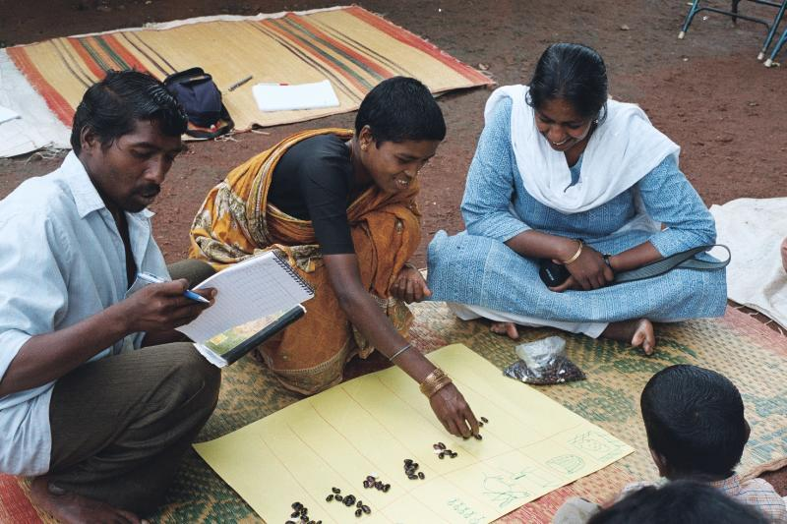

Above: Woman participant conducting individual scoring of project activities

Below: Group discussions in progress

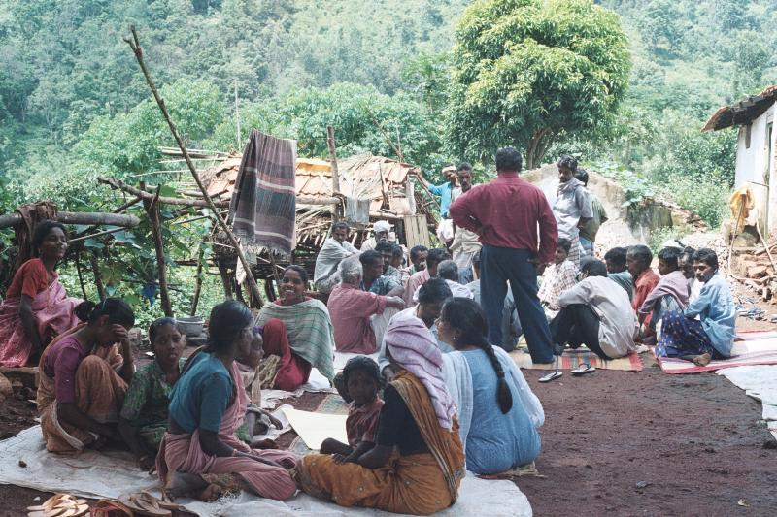

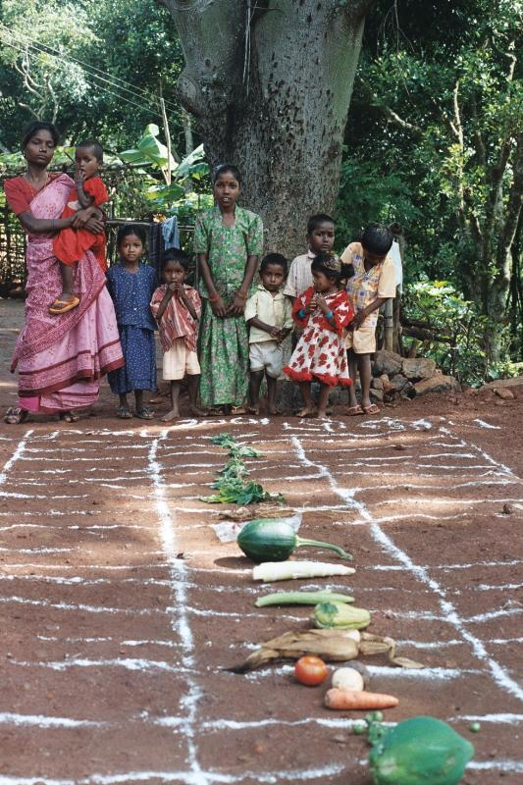

Above: Food diversity exercise – grid laid out for scoring

Food diversity
This exercise was also based on a ranking – this time comparing food diversity before project commencement in 2000 and now, in 2004. Participants helped in gathering samples of all the different foodstuffs they use – ranging from various leafy vegetables (including those gathered wild) to traditional cultivated vegetables, traditional grains, bought rice and bought vegetables. The final collection featured 32 different foods. These were lined up on the ground, and a grid drawn around them for “before” (left side) and “after” (right side), as shown in the photograph. Participants discussed their eating habits, and then one representative of the men and one of the women marked, using beans (maximum score 5, minimum zero), the extent to which a particular foodstuff featured (then) and features (now) in their diet.

Results of the comparison
The results of the exercise were not what Keystone staff expected, as the participants indicated that overall, the diversity in their diet has decreased, not increased, over the last three years. Two comments recorded at the time are indicative,

“In the past we used to pray together, and grow millet together…. Now our community is not so close, people don’t come together for such things.” (Older man)

“We go for coolie work and buy [subsidised] rice at the ration shop… How can we eat a variety of foods when this is so? We have become used to eating rice, and it is so simple to cook and cheap”. (Younger man)

Lessons learned regarding the methods

Overall, participants were more at ease in giving each attribute/criteria a particular score, rather than having to decide on an order of ranking. This also made it easier to combine the views of different individuals to come up with a total score, which could then be turned into a ranking. Perhaps, though, the value of this exercise lay less in the scores and ranking obtained than the process of discussion and self-reflection that it entailed. Although no-one brought up the subject of stronger community organization or better political representation, these are issues that are beginning to be voiced in other villages in which Keystone works.

In some situations, community members may be most comfortable with ranking attributes/criteria relatively, rather than assigning specific numerical values. Pair-wise ranking (comparing two attributes and placing one above another) may be particularly easily understood. However, in other situations – as in this case – people may be more comfortable with a system of numerical scoring. The important thing is for the facilitator to ensure that everyone understands and feels at ease with the method used.

It was unfortunate that women were poorly represented (it so happened that the exercise coincided with a day on which work was available on the nearby estate – so many had gone to take advantage of this cash earning opportunity). However, despite their low numbers, it was important for them to have a separate voice.

At the beginning there was a temptation to include the women in one overall group for the discussions, since they numbered only six. However, it was decided that their views would probably be lost if this was so. Women indeed came out with different ideas from men, and although they sometimes volunteered less information, this could simply have been because they were fewer in number (the men had many more heads to put together).

With regard to food diversity, the results of the exercise stimulated the most thought and reflection. The following factors all probably play a part in the apparent decrease in food diversity.
- Despite careful explanations, many participants still tended to take “before” as many years ago, not just three years back
- This year is the first of good rains during the project period; millet harvests were not so good in the first two years due to drought. Reintroduction of traditional foods takes time – much more than three years
- The availability of highly subsidised rice (only Rs 3/kg) in the ration shops does indeed undermine the programme to a certain extent (the market price of millet is some Rs 12/kg)
- There could be some hesitance in admitting to eating traditional grains in a large audience.

The fact that results were not as expected does not mean that the exercise was “wrong”. Often more can be learned from the unexpected, and from considering why certain responses were given.

Comments of Keystone staff were as follows.

“Maybe the question should have been posed in a different way. We know that in all the tribal settlements they never used to grow millet before 1998 or so, but now millet growing has taken off everywhere…. This rice eating habit is like a status thing. They don’t like to say that they eat millet. If we talked in a smaller group, maybe the result would be different.” (Robert Leo)

“I liked the group discussions. Everyone had a chance to give their views and did – it was a very free discussion. The finding about food habits was a bit discouraging, that millet consumption has not increased as we thought. But the reasons – what they are saying – are correct.” (Nagaraj)

Follow up by Keystone

For Keystone, the information gathered above serves as a base on which to work further; despite the cessation of SDC/IC funding in 2005, the organisation intends to continue work in the villages (with funding from other sources). Keystone also agreed to follow the exercises already conducted with two further investigations.
- Transect walk. It was thought useful to re-conduct a transect walk in one village where it was done three years ago, and note the differences. This should be done with a number of key resource persons in the community, to gain their perceptions of any changes.
- Photographic records. Keystone has kept a comprehensive photographic record of its work. As another way of recording local people’s perceptions of project activities/achievements, they will try to find a number of photos taken at project commencement, and discuss with community members what has changed – either by comparing photos taken recently, or by going directly to the field (if the original photos correspond with the current season and thus bare direct comparison).

CA, Bangalore, 3 November 2004
Annex: Results of Innovation ranking

Women’s group
Cultivation of subsistence crops 7 (4)
Single trench digging for plants 4 (7)
Nursery 10 (1)
Vegetative bunds 6 (5)
Village boundary marking 5 (6)
Check dams 8 (3)
Revolving fund 9 (2)
Compost pits 3 (8)

Men’s group
Cultivation of millet, subsistence crops 10 (1)
Nursery 9 (2)
Planting 5 (11)
Trenches 8 (4)
Gully plugs 8 (4)
Vegetative bunding 6 (8)
Revolving fund 7 (7)
Boundary fence 8 (4)
Honey collection, etc. 8 (4)
Compost pits 3 (12)
Seed bank 7 (7)
NTFP seeds and nursery 9 (2)

LIST OF PARTICIPANTS

Village Samaigudal

- Chinnamani
- Ramkumar
- T. Kalan
- K. Rangan
- Sivan
- M. Sivaraj
- S. Rangan
- M. Vellai
- P. Sevana
- V. Sivaraj
- M. Kalan
- R. Rangasamy
- K. Maruthai
- Laxmanan
- S. Balan
- K. Chandran
- Marappan
- G. Nanjan
- M. Paulraj
- R. Bala
- Murugan
- Masan
- Uday Kumar
- Jammai
- K. Rangasamy
- Sarasa
- Selvi
- Anandhi
- Janaki
- Shanti
- Papi
- Neeli
- K. Madan
- R. Mari
- T. Ramachandran
- P. Rangasamy
- G. Rangasamy

Staff Members Present
Robert Leo
B. Sivaraj
M. Nagaraj
Snehlata Nath

For example, ragi (finger millet), same (little millet), tene (foxtail millet), amaranthus.

