**Kitchen garden (Give India)**

**Personal details**

|  |  |  |  |  |  |  |
| --- | --- | --- | --- | --- | --- | --- |
| **S.No.** | **Name** | **Age** | **Status** | **Settlement** | **,Community** | **Extent of kitchen garden area** |
|  |  |  |  |  |  |  |
| 1 | Malathi W/o late Raghavan | 58 | Widow | Nedunkayam | Paniyan | 13 m x 10 m |
| 2 | Sindhu | 32 | Divorced single | Nedunkayam | Paniyan | 8 m x 5 m |
| 3 | Sarojini W/o Dasan | 37 | Cancer patient | Appankkappu | Kattunaicken | 8 m x 5 m |
| 4 | Chandran H/o Leela | 36 | Locomotor disabled | Appankkappu | Kattunaicken | 8 m x 5 m |
| 5 | Gopi | 60 | Elderly with wife and no children | Eruttukuthi | Paniyan | 13 m x 10 m |

1 Malathi, Nedunkayam

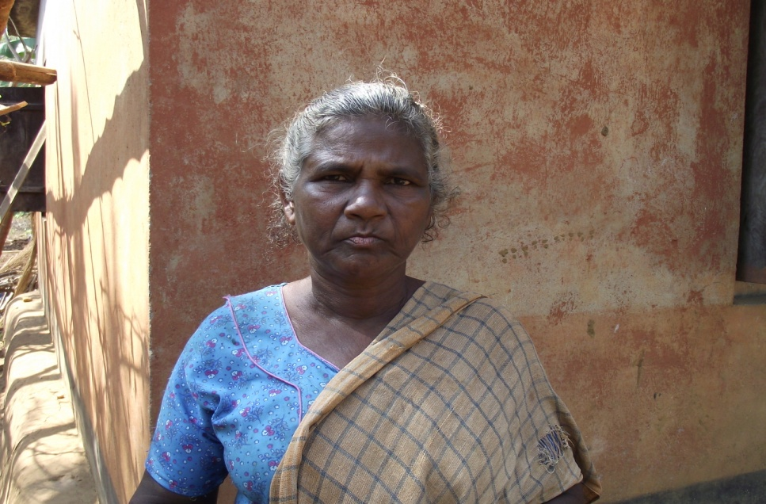

2 Sindhu, Nedunkayam

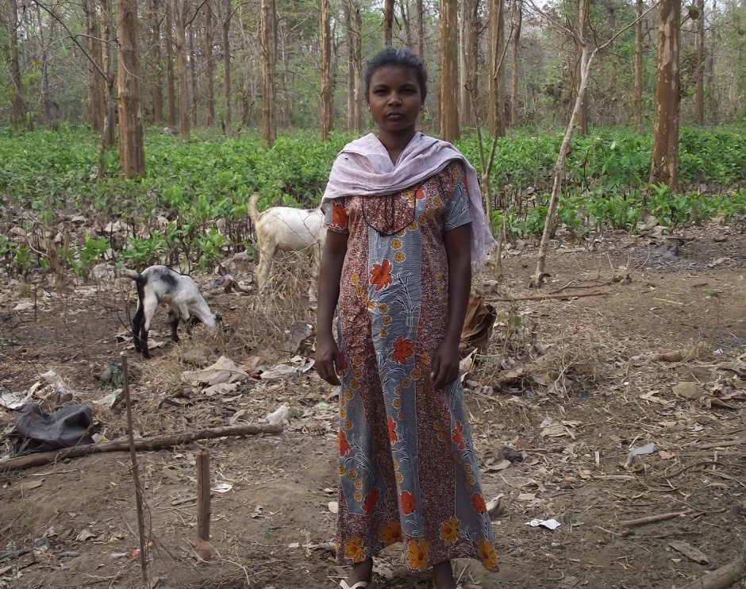

3 Sarojini, Appankkappu

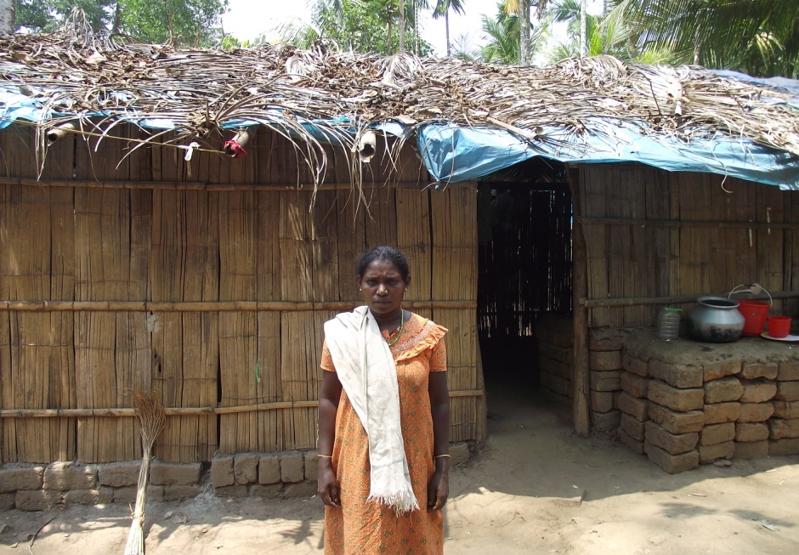

4 Chandran , Appankkappu

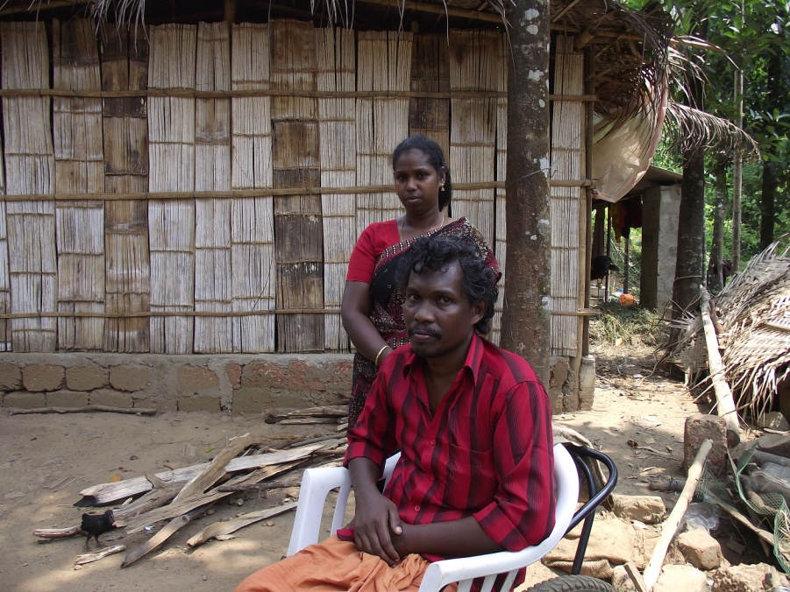

5 Gopi, Eruttukuthi

