**One man’s fight to Conserve a Wetland**

One the 12th of February we Inaugurated the Wetlands and Water Information centre along with a Wetlands park that was set up in partnership with Indco Tea Factory in Kattabettu. The Nabard Chairman inaugurated the space in the presence of the District Monitoring Officer and CEO Indco Serve and District Collector Innocent Divya.

At the same time another wetland in the heart of Kotagiri town was about to be converted for building a Primary Health Centre. Commonly known as the Rifle Range Wetland among the locals after the British initially used the area for training their soldiers on shooting, the traditional name of the Wetland being Ubbaranni Haada is far forgotten.

The name Keirbetta was derived from the Wetland – Keir meaning Wetland and Betta meaning a Hill in the local Badaga language. The villagers have been traditionally using this land and its catchments for grazing their buffaloes. However due to land use changes and other communities moving in and setting up habitations, the grazing areas reduced resulting in the reduction of buffalo population. Today the Land use of the Wetland is as seen in the map below.

*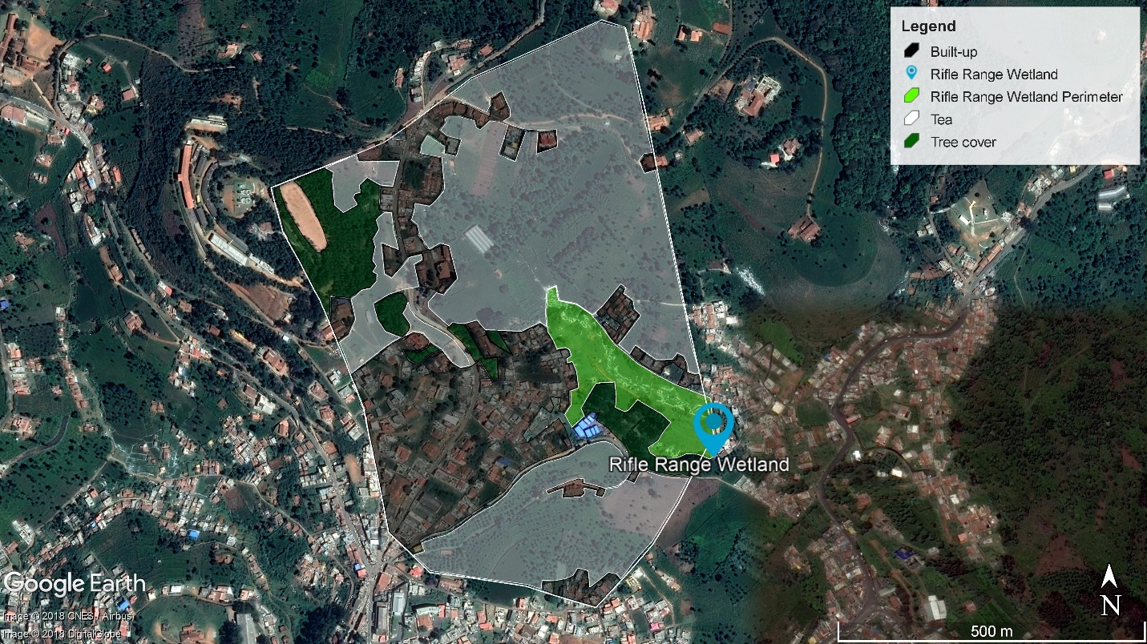Figure 6: Land cover map of Rifle Range overlaid on Google Earth Image*

|  |  |
| --- | --- |
| Total area of catchment | 108 acres |
| Total perimeter of the catchment | 2595 m |
| Total area of wetland | 6.99 acres |
| Total perimeter of the wetland | 1192 m |

*Table 1: Area of the wetland and the catchment*

|  |  |
| --- | --- |
| **Name** | **Area (acres)** |
| Built-up | 28.93 |
| Tea | 55.28 |
| Tree cover | 8.59 |
| Wetland | 6.99 |
| Miscellaneous | 8.21 |
| **Total** | **108** |

Table 2: Land use in the catchment and their area

Figure 4: Proportion of the different land uses

While most of us were unaware of the developments in the wetland, Mr. Raju, who hails from the Keirbetta village also a member of the Longwood shola watchdog committee was on his feet day in and day out to stop the wetland from being converted to a built up. He has been spearheading a lot of such campaigns in the Nilgiris for environmental protection by sending petitions after petitions to various government officials and departments. The local communities, citizens groups and NGO’s have been voicing their objections on such unmindful government projects being planned around wetlands and water bodies across the Nilgiris.

Keystone Foundation has been engaging local communities in the region to conserve this patch of Wetland which provides drinking water to neighboring areas and is the origin of the stream which flows towards Kottacombai to join the Catherine falls river and further down to join the Kallar River at Mettupalayam. The ecosystem service the wetland offers is immeasurable in terms of purifying the pollutants and providing with fresh water to communities and wildlife, cultural value, reservoirs of biodiversity, maintaining local hydrology, supporting perennial flow of water in the stream, flood control and a carbon sink.

Despite the repeated calls for conserving wetlands and water bodies by stopping further encroachment, the decision makers have turned a deaf ear to the people’s pleas. Today one man’s effort and continuous fight has resulted in the government abandoning the PHC project at Rifle Range. But the project has been stopped for only the wrong reasons that the soil is not suitable for the building stability and not because it is an important ecosystem to conserve.

Let us not forget that the Nilgiris district is highly vulnerable to landslides, and recurring flood events in the urban towns is a new normal. This takes us back to square one where we need to re-iterate that these Small Hill Wetland are not Wastelands but important zones for mitigating climate disasters in the region apart from the various services that they provide us.

Until we hear about the next wetland being converted and until the next disaster hits us, let us all go back to our comfort zones and act like nothing happened.