GALITHIMBAM FUELWOOD COLLECTION

Name of Village : Galithimbam
Total number of households : 65
Total landholding size : Estimated 54 Acres
Current list of preferred fuel-wood species : Koli, Vejja, Kunde, Oppe, Pyre,
Vellanaga, Seergoli, Gola, Sodali,
Koya.
Current list of areas for fuel-wood collection : Mathikundi, Adakkal, Periyapaarai,
Athipatti etc.
Approx. requirement of fuel-wood in kgs/hh/week : ~ 36 kgs

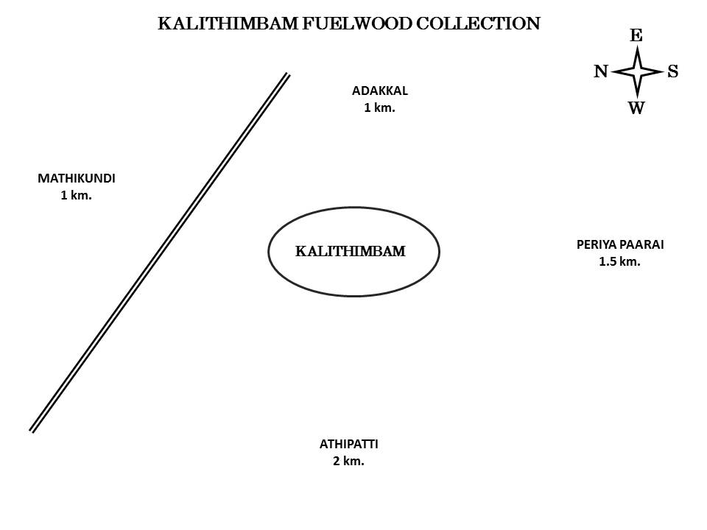
MAVANATHAM FUELWOOD COLLECTION

Name of Village : Mavanatham
Total number of households : 81
Total landholding size : Estimated 92 Acres
Current list of preferred fuel-wood species : Koli, Vejja, Kunde, Oppe,
Vellanaga, Kyne, Kaare.

Current list of areas for fuel-wood collection : Karaipatti, Ponneri, Solai,
Munipari, Yanaisoppala, Kalseray,
Mannkerkuttai, Kootukorai,
Thombu, Saarangunalli etc.
Approx. requirement of fuel-wood in kgs/hh/week : ~38kgs

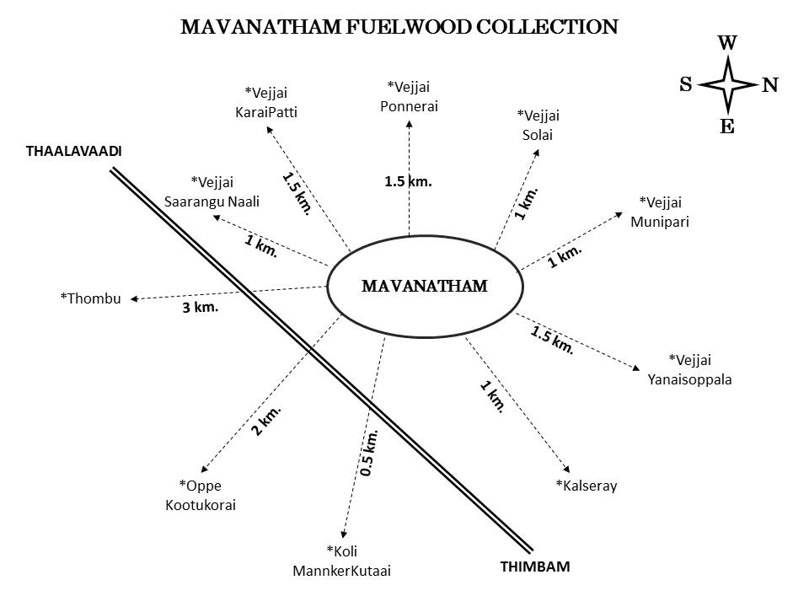
RAMARANAI FUELWOOD COLLECTION

Name of Village : Ramaranai
Total number of households : 15
Total landholding size : Estimated 50 Acres
Current list of preferred fuel-wood species : Vejja, Oppe, Pyre, Neri
Vellanaga, Mukarshi, Seergoli,
Tarani, Lantana, Puda.
Current list of areas for fuel-wood collection : Jaalamaram, Ramarkoil,
Ramarkandi, Ooradapethi,
Kaaturayan, Mookarusimaram.
Approx. requirement of fuel-wood in kgs/hh/week : ~34 kgs

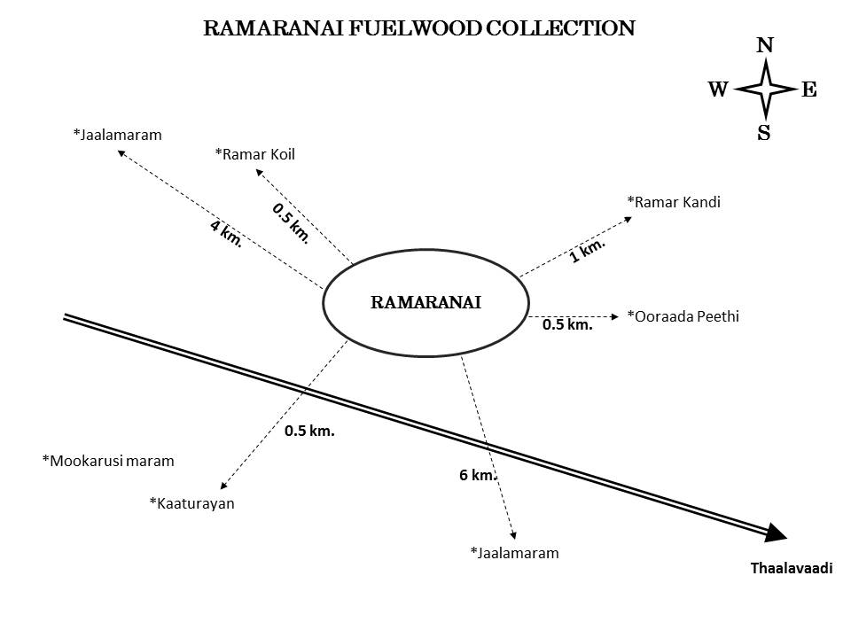
ITTERAI FUELWOOD COLLECTION

Name of Village : Itterai
Total number of households : 54
Total landholding size : Estimated 114 Acres
Current list of preferred fuel-wood species : Koli, Vejja, Kunde, Oppe, Neri,
Vellanaga, Kyne, Jaala.
Current list of areas for fuel-wood collection : Attikorai, Kandikorai, Thadalatty,
Aathurayaada, Kachaaada,
Vethakorai, Vittikandi etc.
Approx. requirement of fuel-wood in kgs/hh/week : 43 kgs

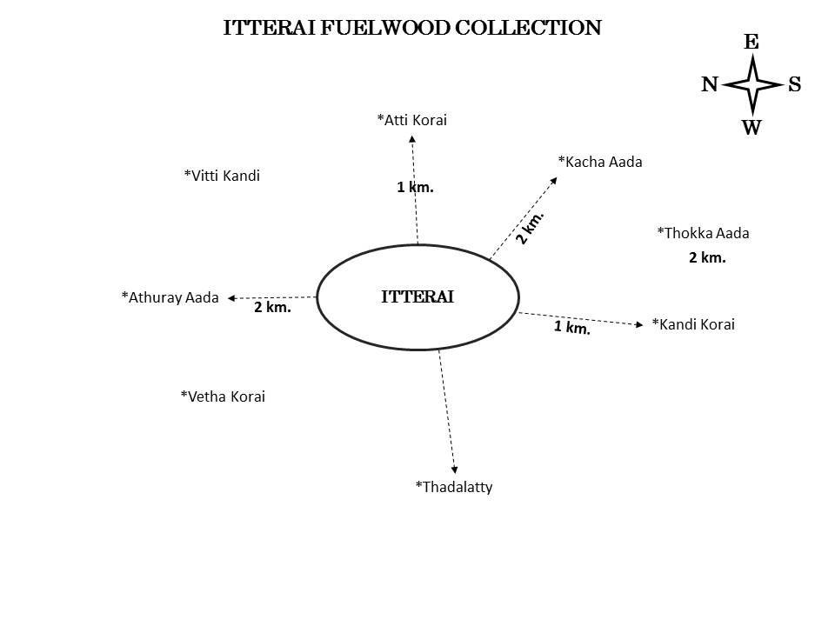
THADASALATTY FUELWOOD COLLECTION

Name of Village : Thadasalatty
Total number of households : 41
Total landholding size : Estimated 54 Acres
Current list of preferred fuel-wood species : Koli, Vejja, Kunde, Oppe, Pyre,
Vellanaga, Tarani,Neri.
Current list of areas for fuel-wood collection : Neerveraiaada, Kumbaarakundi,
Ottithekaada, Kongakkal,
Neernalli, Kerkuttai, Pokkipatti,
Mottiveerainalli, Periyakambiparai.
Approx. requirement of fuel-wood in kgs/hh/week : ~30 kgs

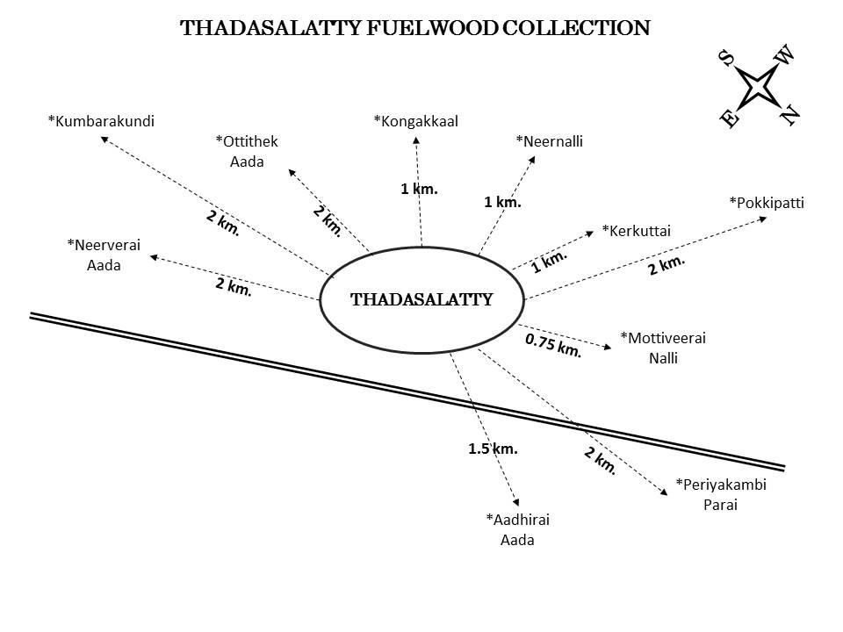
BEJALATTY FUELWOOD COLLECTION

Name of Village : Bejalatty
Total number of households : 57
Total landholding size : Estimated 40 Acres
Current list of preferred fuel-wood species : Koli, Vejja, Kunde, Oppe, Pyre,
Vellanaga.
Current list of areas for fuel-wood collection : Mostly in the village.
Approx. requirement of fuel-wood in kgs/hh/week : ~45 kgs

