<http://www.travel2ooty.com/blog/precautions-for-southwest-monsoon>

Precautions for Southwest monsoon in Nilgiris

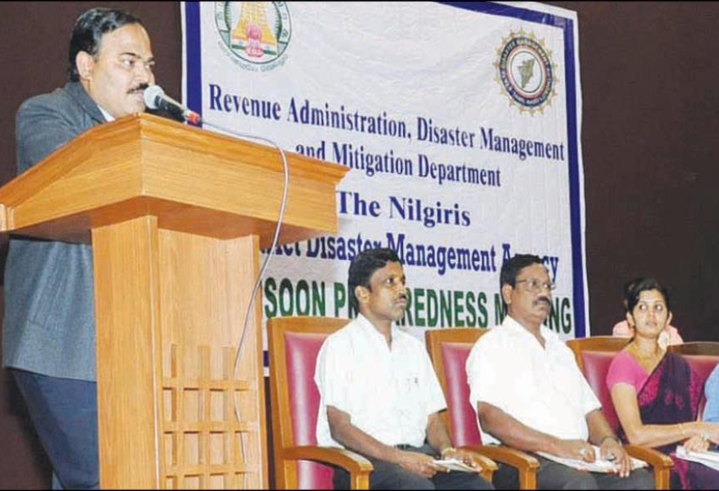Photo Credit: Daily Thanthi**Updated by : Travel2ooty on June/18/2017**

Due to the onset of the southwest monsoon in the Nilgiris district, the district collector of Nilgiris, Mr.Shankar has announced to set up the control rooms in 6 taluks in the Nilgiris districts, to help the public during any emergency in the rainy season.

A meeting was held in the Tribal cultural center in the Nilgiris district, to discuss about the precautionary steps to be taken during the southwest monsoon season. The collector said that around 466 schools and community centers were in ready condition to accommodate the people during any disaster occurring in the rainy season. He also said that the revenue department, police department, fire and rescue service department, highways department, electricity department, public works and civil supplies department have appointed officials to provide relief and rescue operations during the rainy season in the Nilgiris district.

In case of any flood, landslides and tree fall, the public can contact the below numbers and can get immediate relief and rescue operations during the southwest monsoon season in the Nilgiris.

1. Ooty control room - 0423-2445577, 0423-2442433

2. Coonoor control room - 0423-2206002, 0423-2206102

3. Gudalur control room - 04262-261295, 04262-261252

4. Kotagiri control room - 04266-271718,

5. Kunda control room - 0423 -2508123,

6. Pandalur control room - 04262-220734.

The collector also said that immediate action will be taken based on the received information and informed that these control rooms will function for 24 hours per day till the month of December