GALITHIMBAM GRAZING PLANS

Name of Village : Galithimbam
Total number of households : 65
Total landholding size : Estimated 54 Acres
Current list of cattle in the village : 78(Cow-61, Buffalo-4, Goat-13, Hen-2)
Current list of areas for grazing : Ole KambeMalai, Thekkuker,
Senadamaduvu, Koolipadigaipatti,
Pandrikal, Sabbakannkadupatti etc.
Is stall feeding practised? : No
Is fodder grown on the village lands? : No
Vaccination schedules : Once a year for cows, Government vets
come to village once every six months.

Details of grazing patterns
They follow rotational grazing pattern for all the three Livestocks. Once in ten days they tend to change and shift the area of grazing to the nearby one.
Cows, Buffalos : For cows and buffaloes it is during the rainy season where the livestocks are herded into forest as agriculture is practised in the farmlands during rains. So in summer, grazing happens in the periphery of the villages when the field is empty.
Goats: Goats are always accompanied by a herder. They are taken into forest both during rainy and summer seasons.

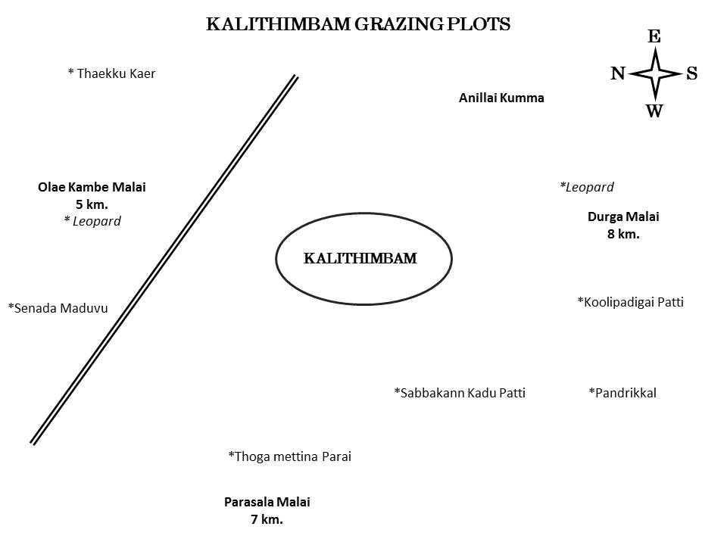

MAVANATHAM GRAZING PLANS

Name of Village : Mavanatham
Total number of households : 81
Total landholding size : Estimated 92 Acres
Current list of cattle in the village : 202(Cow-52, Buffalo-35, Goat-115, Hen-10)
Current list of areas for grazing : GiriMalai, SikkagiriMalai, Parasamalai,
Jaalapari, Keraada, KaaranaKal, Kallipaai
Aaduthalaikuttai etc.

Is stall feeding practised? : No
Is fodder grown on the village lands? : No
Vaccination schedules : Once or twice a year.

Details of grazing patterns
They follow rotational grazing pattern for all the three Livestocks. Once in ten days they tend to change and shift the area of grazing to the nearby one.
Cows, Buffalos : For cows and buffaloes it is during the rainy season where the livestocks are herded into forest as agriculture is practised in the farmlands during rains. So in summer, grazing happens in the periphery of the villages when the field is empty.
Goats: Goats are always accompanied by a herder. They are taken into forest both during rainy and summer seasons.
:
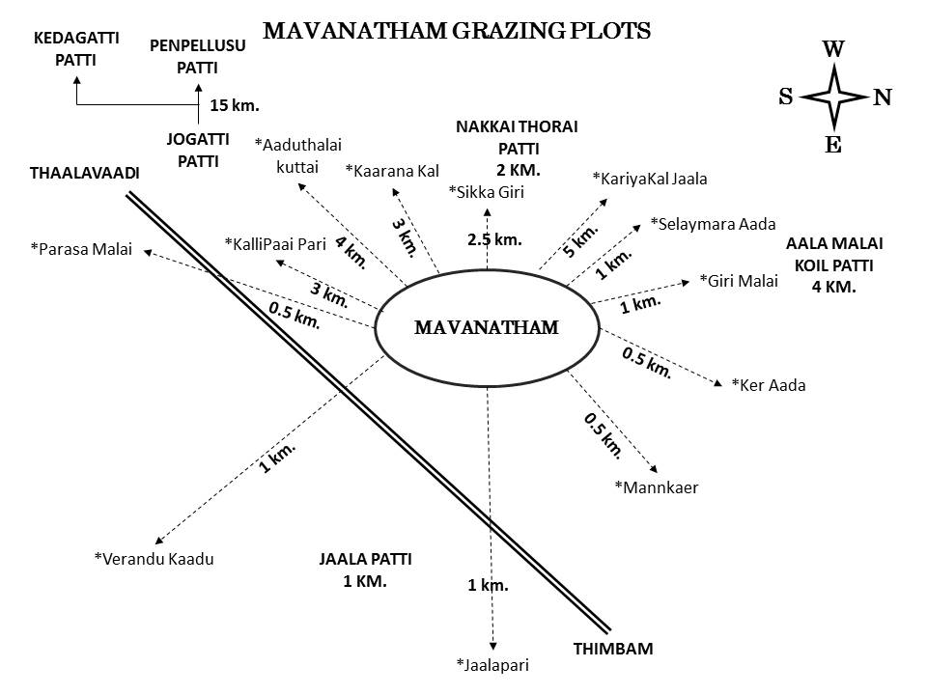

RAMARANAI GRAZING PLANS

Name of Village : Ramaranai
Total number of households : 15
Total landholding size : Estimated 50 Acres
Current list of cattle in the village : 62(Cow-13, Buffalo-0, Goat-49, Hen-4)
Current list of areas for grazing : Makthikundu, Ramarkandi,
Kaaturaayakoil etc.
Is stall feeding practised? : No
Is fodder grown on the village lands? : No
Vaccination schedules : Once a year.

Details of grazing patterns
They follow rotational grazing pattern for all the three Livestocks. Once in ten days they tend to change and shift the area of grazing to the nearby one.
Cows, Buffalos : For cows and buffaloes it is during the rainy season where the livestocks are herded into forest as agriculture is practised in the farmlands during rains. So in summer, grazing happens in the periphery of the villages when the field is empty.
Goats: Goats are always accompanied by a herder. They are taken into forest both during rainy and summer seasons.

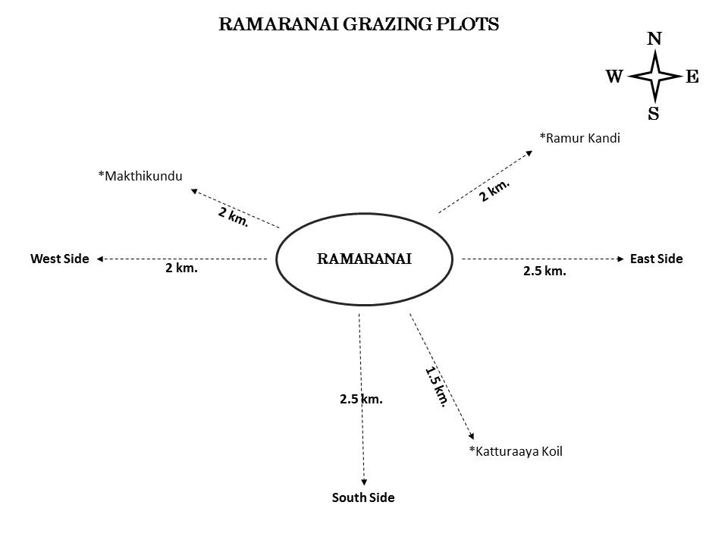

ITTERAI GRAZING PLANS

Name of Village : Itterai
Total number of households : 54
Total landholding size : Estimated 114 Acres
Current list of cattle in the village : 163(Cow-103, Buffalo-30, Goat-30, Hen-54)
Current list of areas for grazing : Mathikundi, Paairai,
Thundikorai, Paarasaalaimalai,
Ottisaalla, Kappikanalli etc.
Is stall feeding practised? : No
Is fodder grown on the village lands? : No
Vaccination schedules : Once or twice a year for cows.

Details of grazing patterns
They follow rotational grazing pattern for all the three Livestocks. Once in ten days they tend to change and shift the area of grazing to the nearby one.
Cows, Buffalos : For cows and buffaloes it is during the rainy season where the livestocks are herded into forest as agriculture is practised in the farmlands during rains. So in summer, grazing happens in the periphery of the villages when the field is empty.
Goats: Goats are always accompanied by a herder. They are taken into forest both during rainy and summer seasons.

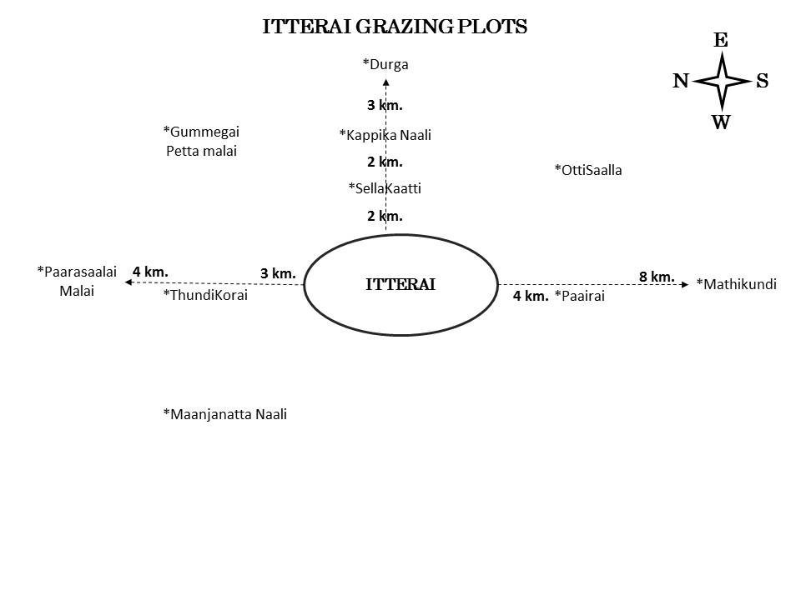

THADASALATTY GRAZING PLANS

Name of Village : Thadasalatty
Total number of households : 41
Total landholding size : Estimated 54 Acres
Current list of cattle in the village : 79(Cow-27, Buffalo-6, Goat-46, Hen-19)
Current list of areas for grazing : Paarasanamalai, Thaarasupani,
Pokkipatti, Thasaraipallam,
Neernalli, Mathikundi, Kumbaarakundi.
Is stall feeding practised? : No
Is fodder grown on the village lands? : No
Vaccination schedules : Once a year for cows and goats.

Details of grazing patterns
They follow rotational grazing pattern for all the three Livestocks. Once in ten days they tend to change and shift the area of grazing to the nearby one.
Cows, Buffalos : For cows and buffaloes it is during the rainy season where the livestocks are herded into forest as agriculture is practised in the farmlands during rains. So in summer, grazing happens in the periphery of the villages when the field is empty.
Goats: Goats are always accompanied by a herder. They are taken into forest both during rainy and summer seasons.

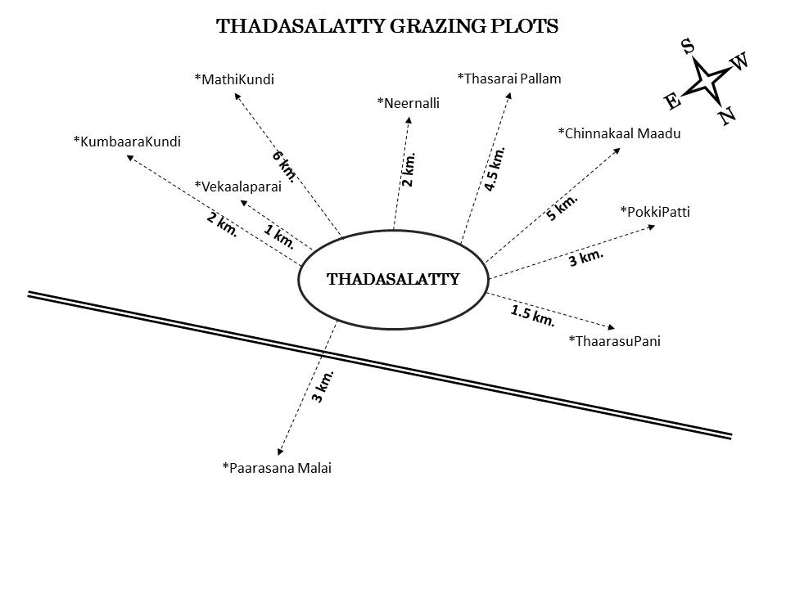

BEJALATTY GRAZING PLANS

Name of Village : Bejalatty
Total number of households : 57
Total landholding size : Estimated 40 Acres
Current list of cattle in the village : 57(Cow-44, Buffalo-8, Goat-5, Hen-22)
Current list of areas for grazing : Village periphery and inside forests.
Is stall feeding practised? : No
Is fodder grown on the village lands? : No
Vaccination schedules : Once a year, Vets come to village through
“Mobile Camp”.

Details of grazing patterns
They follow rotational grazing pattern for all the three Livestocks. Once in ten days they tend to change and shift the area of grazing to the nearby one.
Cows, Buffalos : For cows and buffaloes it is during the rainy season where the livestocks are herded into forest as agriculture is practised in the farmlands during rains. So in summer, grazing happens in the periphery of the villages when the field is empty.
Goats: Goats are always accompanied by a herder. They are taken into forest both during rainy and summer seasons.

