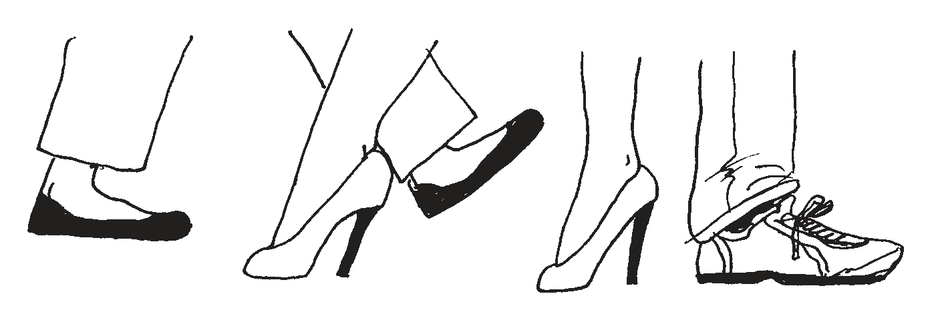

Take a Walk

OBJECTIVES

* To discover the ways in which we are similar to and different from others on our team
* To appreciate the benefits of a diverse team

Group Size - Any

Materials- None

Time – 10 to 15 mins

**Procedure**

Have participants pair up. Each partnership stands face to face and a comfortable distance (about three feet) apart to begin. Tell them they will be discussing the ways in which they are different from, and similar to, their partner. As they discover a difference, they must move a step away from each other. As they discover a similarity, have them move a step closer.

**Tips**

The differences are usually things we can see, such as hair color, height, age, and so on. The similarities are often things that have to do with characteristics, preferences, and personality, which require more conversation and questions to discover.

**Discussion Questions**

1. How far apart did you get before you looked for some similarities?

2. How close did you get before you looked for more differences?

3. Why is it important to balance the two?

4. How does a team benefit from a balance of the two?

5. What did you notice about your differences?

6. When do differences in people in a group prevent reaching certain objectives?

7. How do these differences strengthen the group as a whole?

8. What would this group be like if there were very few differences in people? How would you feel if this were so?

9. What did you notice about your similarities?

10. How do our similarities help build trust within our team?

Diversity Pays

Award each team member 1 point for each base category that applies to him or her. Bonus points are awarded in addition to the base category points. For example, if every member of a team of ﬁve is born in a different state and one team member is born in a different country, the team gets 5 base points plus 5 bonus points for a total of 10 points for the category.

|  |  |  |  |  |  |  |
| --- | --- | --- | --- | --- | --- | --- |
| **Base Category** | **Base Point Value** | **Team Base Points** | **Bonus Category** | **Bonus Point Value** | **Team Bonus Points** | **Total of Columns 3 + 6** |
| Each different birth month | 1 |  | Born on a holiday | 3 |  |  |
| Each different birth state or country | 1 |  | Born in a different country | 5 |  |  |
| Each different eye color | 1 |  | Green eyes | 2 |  |  |
| Each sibling | 1 |  | No siblings Twins Triplets | 3  5  10 |  |  |
| Each village visited (not just a stopover) | 1 |  | For visiting 5  For visiting 7 | 10  15 |  |  |
| Each language spoken ﬂuently | 1 |  | Sign language 3+ languages | 5  10 |  |  |

DIVE RSIT Y

H A N D O U T

|  |  |  |  |  |  |  |
| --- | --- | --- | --- | --- | --- | --- |
| **Base Category** | **Base Point Value** | **Team Base Points** | **Bonus Category** | **Bonus Point Value** | **Team Bonus Points** | **Total of Columns 3 + 6** |
| Each different musical instrument played | 1 |  | 3+  instruments Played professionally | 5  7 |  |  |
| Each year married | 1 |  | 10+ years (to one person) 20+ years (to one person) | 5  10 |  |  |
| Each living parent | 1 |  | Grandparent Great- grandparent | 3  5 |  |  |
| Each state lived in | 1 |  | Different country lived in | 5 |  |  |
| Each different job | 1 |  | 10 + years in one job  20+ years in one job | 5  10 |  |  |
| For visiting the following: Grand Canyon, Pyramids of Giza, Eiffel Tower, Taj Mahal, Great Wall of China, Stonehenge, Great Barrier Reef | 1 |  | For visiting 3+  For visiting 5+  For visiting all 7 | 5  10  15 |  |  |
| **Total** |  |  |  |  |  |  |

|  |  |
| --- | --- |
| **Diversity Pays** | Duration: 15 mins |
| Instruction:  Award each team member 1 point for each base category that applies to him or her. Bonus points are awarded in addition to the base category points. For example, if every member of a team of ﬁve is born in a different state and one team member is born in a different country, the team gets 5 base points plus 5 bonus points for a total of 10 points for the category.  Tips  You can start with a simple fifty-fifty split, which is the fastest and easiest. Once they have the idea, allow the teams some flexibility to classify themselves into additional subgroups.   |  |  |  |  |  |  |  | | --- | --- | --- | --- | --- | --- | --- | | **Base Category** | **Base Point Value** | **Team Base Points** | **Bonus Category** | **Bonus Point Value** | **Team Bonus Points** | **Total of Columns 3 + 6** | | Each different birth month | 1 |  | Born on a holiday | 3 |  |  | | Each different birth state or country | 1 |  | Born in a different country | 5 |  |  | | Each different eye color | 1 |  | Green eyes | 2 |  |  | | Each sibling | 1 |  | No siblings Twins  Triplets | 3  5  10 |  |  | | Each village visited (not just a stopover) | 1 |  | For visiting 5  For visiting 7 | 10  15 |  |  | | Each language spoken ﬂuently | 1 |  | Sign language 3+ languages | 5  10 |  |  |   Discussion Questions   1. What did it take to find out and think about each other in different ways? 2. What makes a classification positive/helpful rather than negative/prejudicial? 3. How does this affect the interactions and contributions of team members? 4. How does this influence our ability to collaborate? 5. How can this experience help us in the workplace? | |
|
|