 | Source | Date | Beneficiary | Identity
1 | SMHT |  | Malathi W/o late Raghavan, Paniyan tribal women aged 58 years old, lives in Nedungayam village.  Nilambur region | 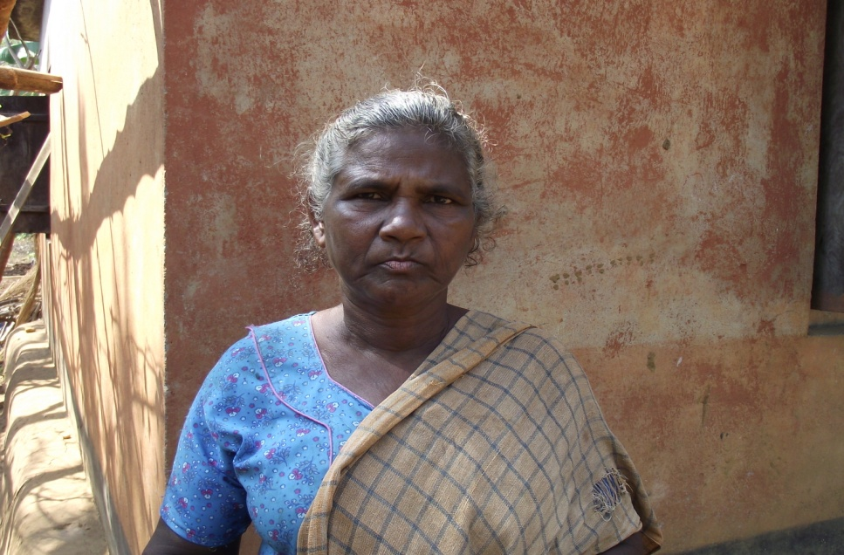
2 | SMHT |  | Sarojini W/o Dasan, Appan kappu, Kattuniackan-is sick  Nilambur region | 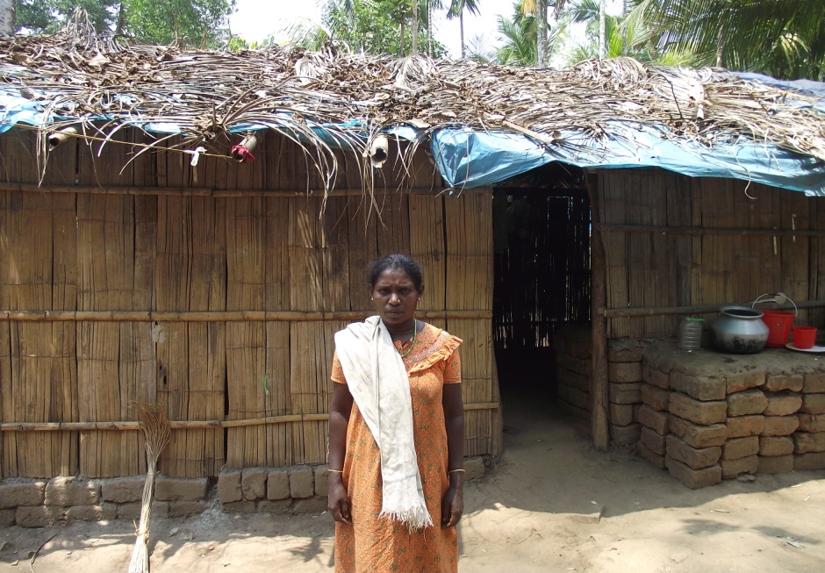
3 | SMHT |  | Irula tribal women, lives in Korapthy village,Pillur region.  (pending sudakar) | 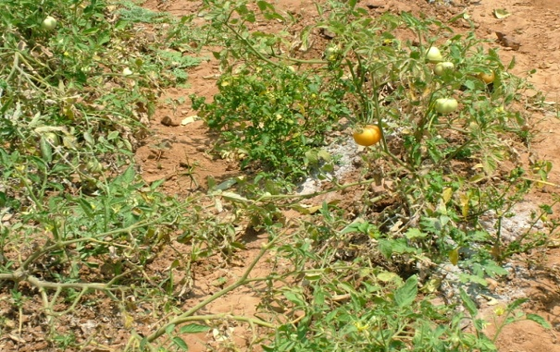
4 | SMHT |  | Seli, widow women lives in Kilpillur village. | Pending from Sudakar
5 | SMHT |  | Basuvan, aged 41,Sumati wife has two children, Irula tribal man, Handicapped, lives in Boothanatham village Sigur region. Always depends on vegetable cultivation. He also sells vegetable to neighbours | 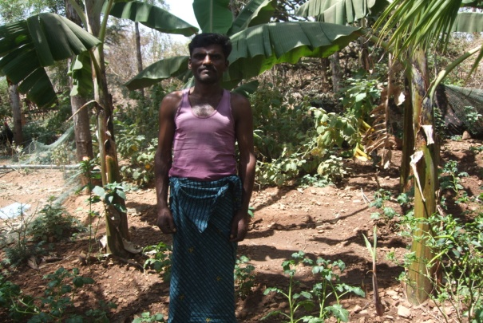
6 | SMHT |  | Basuvan, aged 38 sick man, unable to go for out side wage earning. Always dependent to his back yard cultivation which provides food and income from locally selling vegetables. | 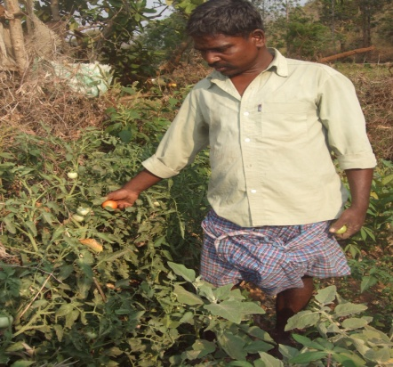
7 | GI |  | Laxmi, siriur | Photo Pending from Justin
 | GI |  | Laxmi,Neergundy pudur, Assanur region | Report is already produced
8 | GI |  | Neeli, | Report is already produced
9 | SMHT |  | Gowri, Irula tribal widow woman, lives in Ittari village has one son. | 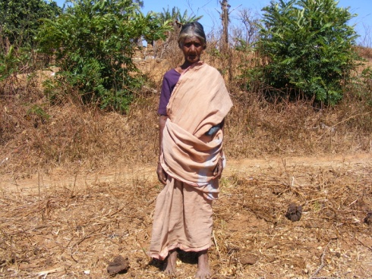
10 | SMHT |  | Shanti,Kurumba tribal widow woman has a son, lives in Ramaranai village | 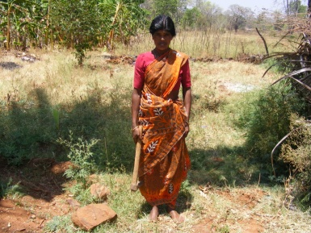
11 | SMHT |  | Laxmi, Kurumba tribal widow woman,aged 48 entirely dependent to vegetable and food crops from her own cultivation. She is from Neeralcombai village | 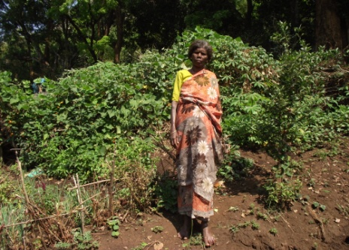
12 | SMHT |  | Rengan, aged 51, Kurumba single man, sick, unable to go for wage earnings. Totally dependent to small scale NTFT gathering and growing food crops from his own land | 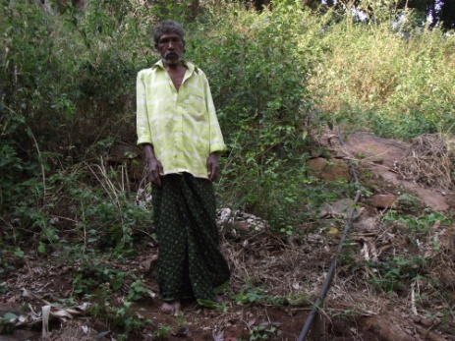
13 | SMHT |  | Blocked;Bundy and wife, entirely dependent to backyard land, unable to go for wage earning due to ill health | (Pending)
14 | SMHT |  | Johee, amputee Kurumba & Rukumani Kurumba tribal widow woman, entriley dependent to cultivation. | Photo pending with MC
15 | SMHT |  | Laxmanan, aged 55 lives in Gudagur with his wife. Elderly couple, unable to go for wage earnings. | Photo pending with MC
16 | SMHT | 12.3.12 | Sarasu w/o late Rengasamy, Kurumba tribal woman. | 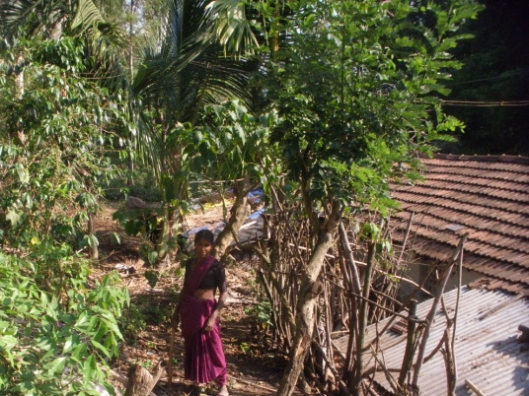
17 | SMHT | 12.3.12 | Selvi w/o late Arunagiri. Irula tribal woman Lives in Neeradi village,Pillur region has four children. | Photo pending with Sudakar
18 |  | 14.3.12 | Sivamma, Sholiga tribal woman,lives in Gethesal village. | 