Millet initiatives: Traditional millet farming in Nilgiri Biosphere Reserve:
By Robert Leo, Keystone Foundation, www.keystone-foundation.org
Keystone Foundation is a registered Trust, working in the fields of environmental conservation, Livelihoods securities for Indigenous communities and Environment Governance. Keystone aims to work with a conscious goal to enhance the quality of life and the environment. Since 1995, Keystone is based in Kotagiri, Nilgiris, Tamil Nadu and has been undertaking a variety of programmes- the main initiatives under livelihood gamut like promoting Apiculture, forest Honey harvesting, Water Resource Management, Land Development, revival of Traditional Agriculture, Non Timber Forest Produce & value addition and marketing of tribal organic produce, etc.
Background: Land use change has taken place in the Nilgiris Biosphere region over the last four decades rapidly towards commercial species, both in the forest and in agricultural lands. The trader’s supported contract system (commercial cattle feed companies) brings in chemical inputs and offering un-fair price because of credit system. This project is supported the tribal farmers in the Nilgiri region, whose lands are fallow, steep and with a very low soil cover. It has also been realized that the soil and water regime in these hill tracts is very vulnerable and requires inputs for improvement/conservation. This is mainly because these land holdings lie very close to steep forested areas of the Nilgiris
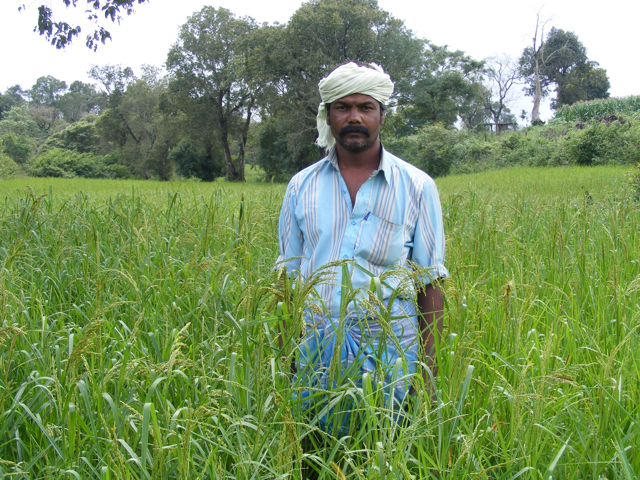

Traditional millet cultivation practices in NBR:
Araganai; The knowledge on splitting the young millet plants manually is locally called as Araganai. Millet is a fibrous root plant which can produce many shoots or tillers as its root base/clump are manually splits at young age. This science is understood by this community for generations before and the operations continue even today through very simple practice across the entire region. This cultivation method is as good as transplanting system ultimately to give vigour growth, many shoots & earheads and optimum harvest.
Land preparation- The plateau is a undulating landscape, traditional land ploughing, burrow preparation, levelling, brining manure into field were carried out with help of bullock.
Ugathi pandigai; on this day a ceremony is performed on the middle of millet field. A wooden stupa/accapacca is placed. This is decorated with traditional leaf bunch believed to be disease, pest and evil repellents. There are leafs which also represents indigenous and the prosperity with nature Goddess. Later, this same wooden stupa is used as pivot to tie stone thrasher in thrashing yard. The farmer brings all traditional seed in a basket and placed near the stupa. These seeds are from his previous year’s harvest which was grown, harvested, preserved locally. Also another basket with dupa, banana and coconut for the ritual is placed. The plough with bullocks, a basket of farmyard manure also is brought to the site. The Village Gowda-head man perform praises the nature god for good weather and protection from wild animal and for good harvest, and handful of seed is sown in a corner of the land as the cultivation operations begun for the year.
Pre ploughing ritual for cultivation of Millets:
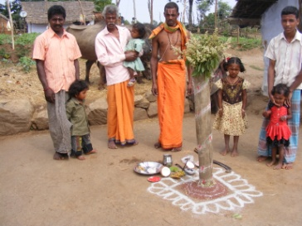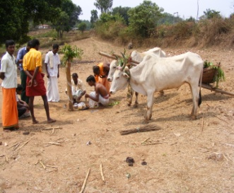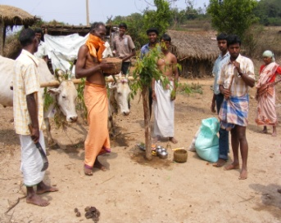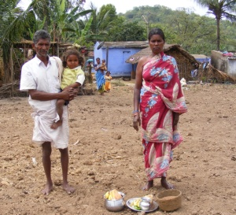
Seed sowing season; first shower-southwest rain begins in early June and the ploughing of millet land starts. With the first shower soil loosens, bio debris and dust settles and able to plough with bullocks. Adi the Tamil month begins on 17th July is popularly known as seed sowing season ie. Adi pattam. On 18th of month Adi (3rd July) major rituals were performed and seeds are sown. If the day is not a Tuesday or a Thursday, a symbolic sowing is observed and major seed sowing takes place on the upcoming Tuesday. This community never sow seeds on other days of the week.
The Plough: a wooden plough is locally made with forest wood Sengonche (is a hard wood and lost for years and the sharpened edge is supported with flattened & sharpened iron rod called as Golu. The ploughing is preferred by the men folk, youth are trained to undertake this work some time even at the age of eight. The cross bar is made of Goolie wood (Melina arborea) as it is light in weight and strong. The driving guide is made of Peethai wood. The ropes or reins are woven with forest fibre. Essentially the plough bullocks are nose knotted at young & reins are connected to it.
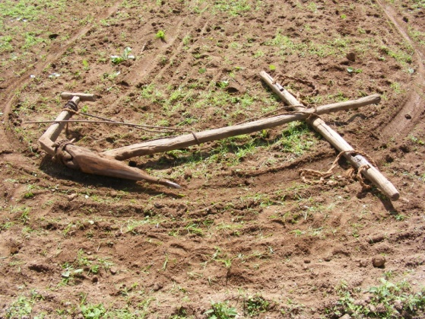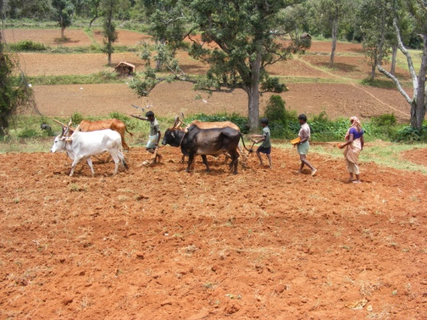

Alumane; it is a locally made tool, exclusively for Araganai purpose. It is made up of either completely with wood or partly with wood & Iron. Wooden or iron pegs are
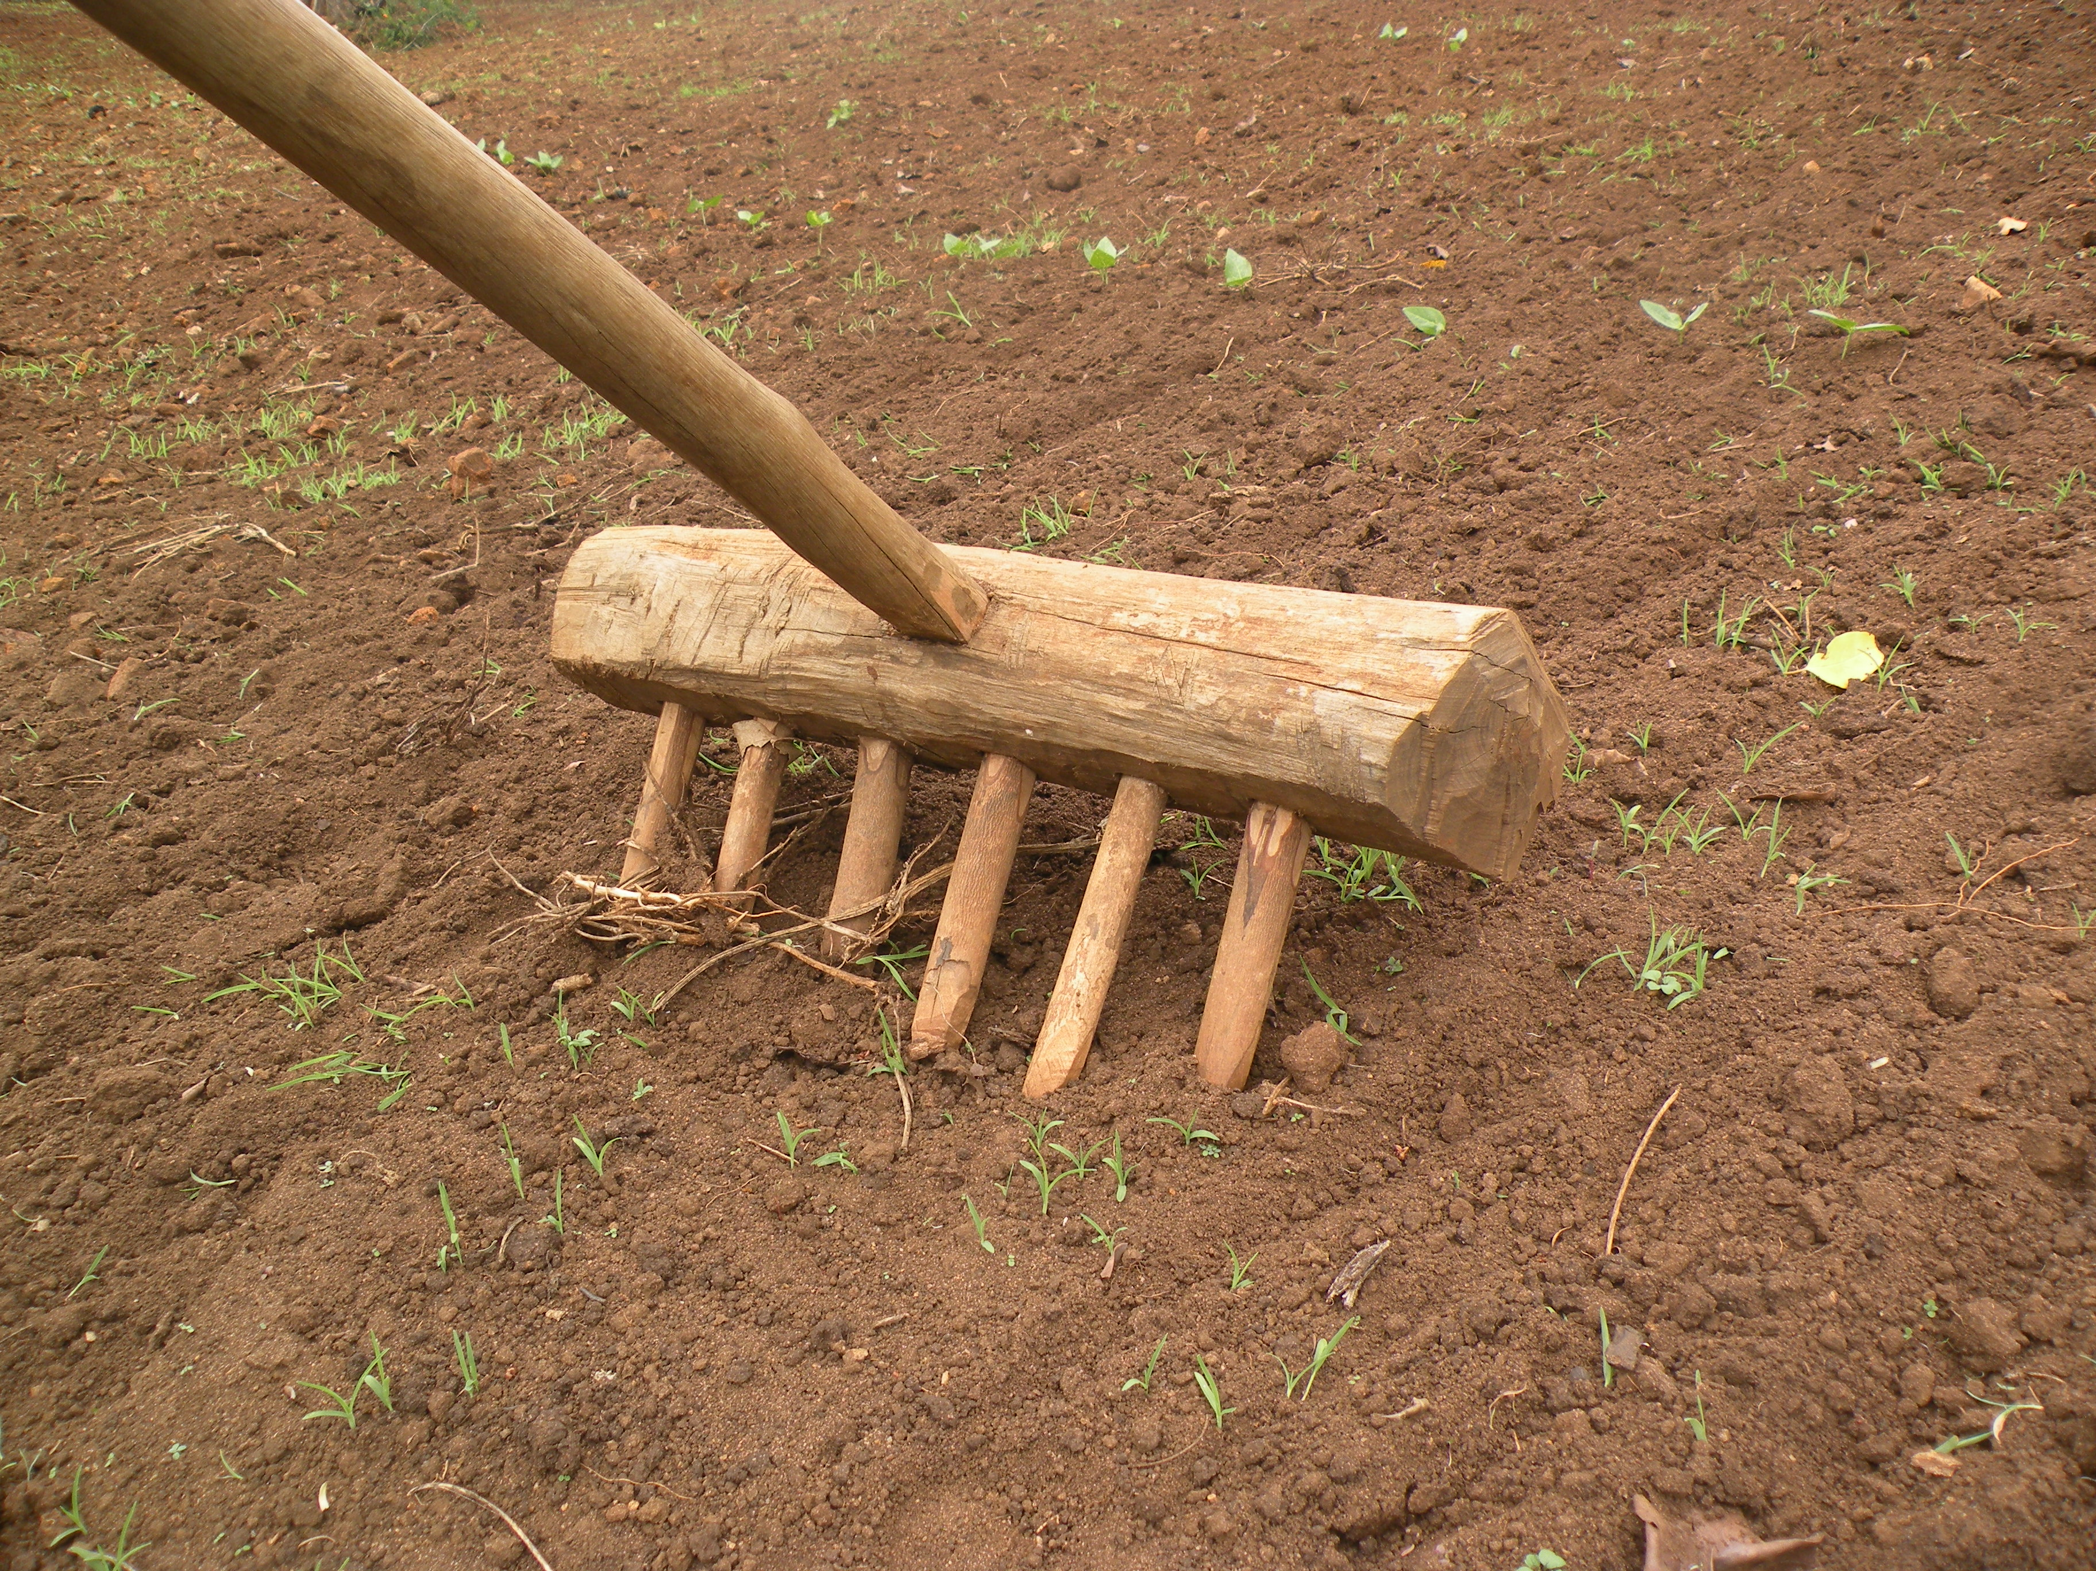
fixed on this as like a big rake. The wooden block is about 6inches thick,
5 inches width, and 2.5feet in length. Pegs are inserted with inter distance
of 4inches. The total length of the pegs is about 8inches, 2inches are inserted
into wooden block and 6inches length left out side.
This is attached with long Pole as drive stem as about 9feet in length. The drive
stem is tied on to Cross bar on pair of bullock or dragged manually. While
dragging, the pegs tear open the field and millet seedlings too.
Traditionally, a well dried Asirai wood is selected and handle with thadachi wood.
The pegs are with dried Koli tree(ligustrum perrotiti) which is hard & never warp.

The Aragani operation - it is practiced on Samai and Ragi (little millet and Finger Millet) crops.
1st - Araganai: 8-10th day after seeds are sown The dragging of Alumane during the first time is up and down towards the slopes of the ground. This is either by manual strength or with bullocks. The depth of the digging is about 2inches and width is also 2incehs. The inter space between the pegs are about 4inches. The digging and splitting the plants proceeds with 4inch clearance. The field bean, maize and mustard or streamlined in between this gap
2nd- Araganai after 14-16 days from first Aragnai (24-26days from day of seed is sown) during this time it is essentially with Kallappe with bullocks with hence the
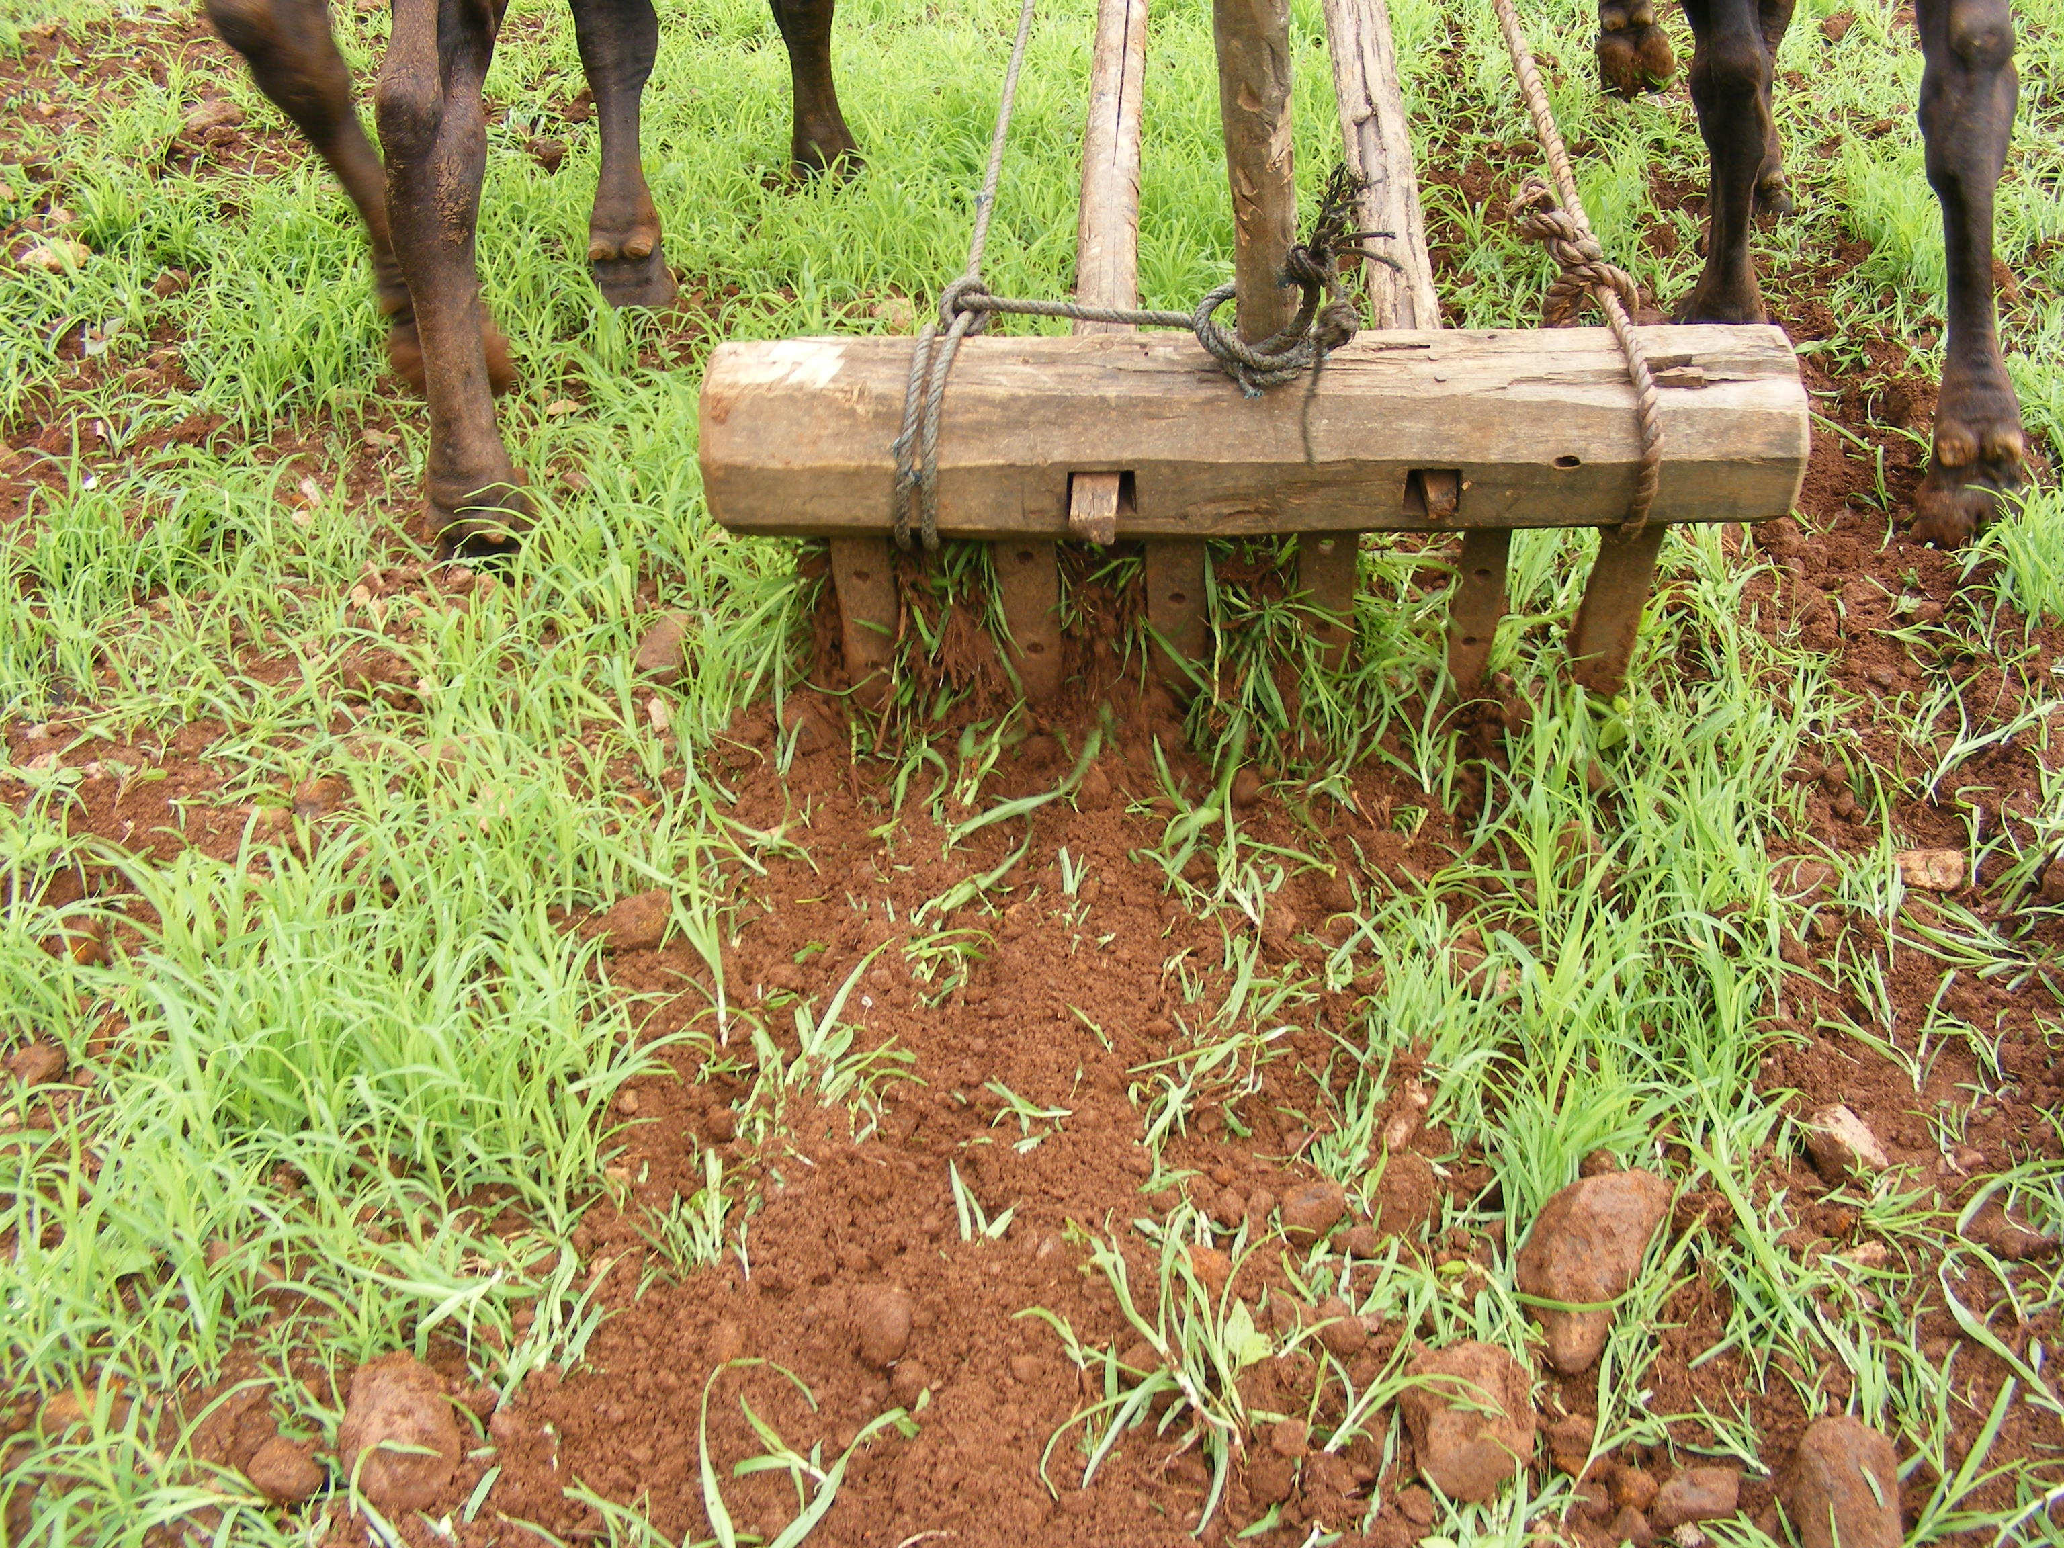
crop is grown higher and direction of Araganai is cutting across first drag
or parallel to the slope. Kallappe is 4ich wide and heavy can be dragged
only by bullocks. While dragging the kallappe earth is wide open to 6inches
and depth of 4icnhes and soil is raised to support the millet plant.
The depth and width is for harvesting rain water and the track is parallel
to slope and control soil displacement.

3rd –Araganai is practiced if the crop is dense, even after two Araganai operations.
4th Cattle grazing method: as to get result of Araganai This is a controlled gazing method with minimum number of cattle are (three or four Buffalos or cattle ) drove into finger/little millet field to graze the crop. The plants are about 4inch height and around 28 days from date of sowing. By doing this the crop is trimmed and the plants are tampered by cattle hoof. The young plants root base is broken and many fresh tillers appear.
Weather on the day of Araganai: it is done on a sunny weather, dry soil, expected to have similar weather for next two days. When soil is moist, splitting or breaking plants at ground level is not sufficient. The uprooted weeds and unwanted plants will dry if sunny weather continues.
The Araganai story: How did this Araganai evolved ?
Ayasamy, village Gowda(traditional village headman) describes the story that he heard from his great grand father of Ittarai village. In a hamlet, a family of two brothers holding a large millet field, traditionally practiced slash and burn centuries ago. In a sowing season, one day while playing, children fight turned out to become a major elder’s fight between the brothers and wanted to become separate families. With his anger, one brother ploughed the newly germinating millet filed, also grazed out the millet with buffaloes and damaged the filed as much as he could do and he left the hamlet with his family. An elderly old man in the family fenced around this field and protected hoping the anger brother one day will return to his field. What a surprise & wonder that the damaged millet crop has grown so fast, had well developed crown and many ear heads. This was observed by the village mate and learned the knowledge.
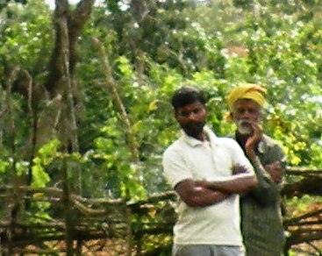

- Karupanraj the Bejelhati village farmer describes the term as Aragani (araku + anai ) Aaraku means scrap/trimming / slicing and anai means keep or raise soil with

- Crop height control Grazing method; Type two; this practice is done at the time of perfuse stalk growth. The farmer hold the reins of the bullock and taken in to the field to eat out the stalk. Especially the crop is at young before the flower stalk is set. The earheads or panickles will lodge on the ground as tall the plant grows.

The Alumane-prime tool for Arangani:
- The traditional Alumane: Craftsman ship is learnt by them selves the Wooden thick bar is 6inch thick, 5inch wide and 36inches length, made of well dried Asirai wood.
- The pegs are 1inch thick and eight inch length-out of which 2inche inserted inside the wooden bar.
- These pegs are lingustrum wood, hardy, slightly curved towards drive pole section of the Alumane.
- The tip of the pegs is sharpened as flat.
- The pegs are fixed about 4inches inter space.
- The drive bar (long pole-handle) is prepared from well dried Peesundai plant.
- The cross –Bar to tie pair of bullocks, is made from Melina Arborea plant
- A normal wooden manual is about 14-15kgs, sand filled bag or stone is tied on top to increase the weight, if they feel the digging depth is not sufficient

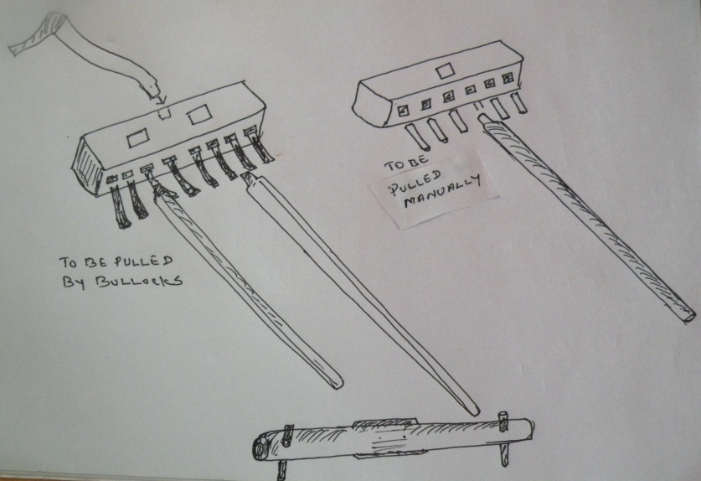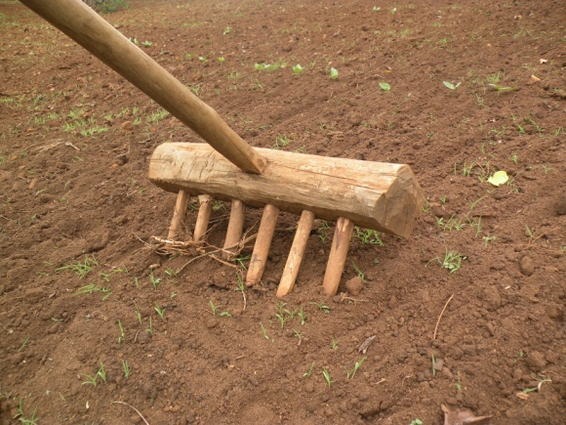

Alumane made of flattened iron pegs(efficient) Alumane made of Iron rod as pegs(less effective) 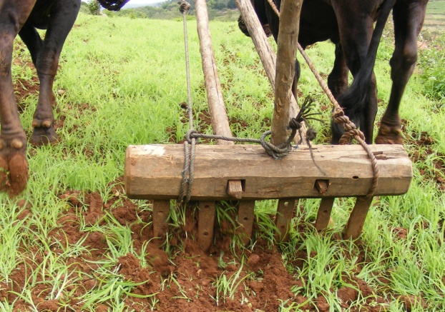 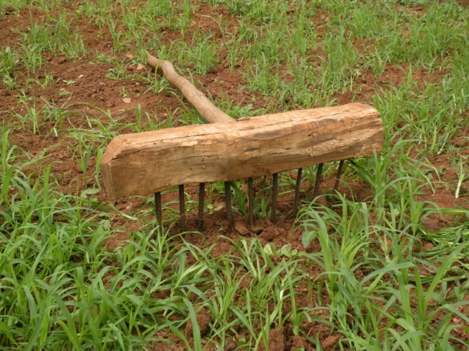

The perception & reasoning of Aragani by farmers & elders:
- Splitting roots & clump, flattening at ground level many tillers appear i.e., more tillers, larger crown, uniform sizes, uniform height,
- Tinning; the seeds are broadcast, tend to grow more plant than what is required. Thinning will increase interplant space, aeration to the plant, less competition for nutrients.
- Loosening soil; dragging with alumane or kallape, aeration is created,
- Weeding; the weeds are uprooted and mixed with soil as decomposed as green manure
- Moisture retention will increase as weeds decomposes
- Water percolation; the ground is loosen, burrows harvest rain water and percolation take place.
- Karupanraj describes the term as Aragani ( aragu + anai ) Aaragu means trimming or slicing or sharpening and anai means keep or raise soil with
- M.Mari,thadaslhatti village, without aragani the crop is a waste there is nothing to harvest. Only fodder you will get.
- According to Mani; we want good yield, Aragani is to make damage to the seedling as much as possible, that has to be equal to a destruction made by an enemy or jealously person to your crop.
- According to Resan, Thadasalhati, if you don’t do aragani the crop will be with single stalk and smaller earheads. Araganai helps to get uniform crowns, uniform heights and you can keep a basket on the plants.
Millet is a community crop: Craftsmanship &Sharing of the tools; Most of the farmers themselves collect forest wood and make their own Alumane. The basic tools for such craft is owned, borrow from another farmer within the village. Similarly, sharing of Alumane, kallappe and bullocks too are practiced without money. Such exchanges and some quantity of harvested grains are complimentary. This system enhances the efficiency in farming and strengthens the community bondage. Craftsmanship &Sharing of the tools
Zabbai- is a local tool made with bamboo branches.
A bunch of branches spread as flat dove tail and tied with a
drive pole. While dragging this zabbai sharp
twigs and hook drag weeds, and with a weight soil is
spread level and even. The seeds get covered with 1inch soil
cover
Traditional finger millet thrashing stone Zabbai,
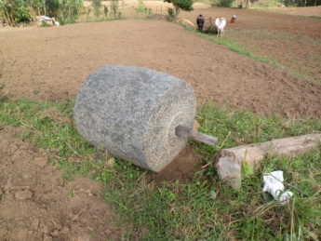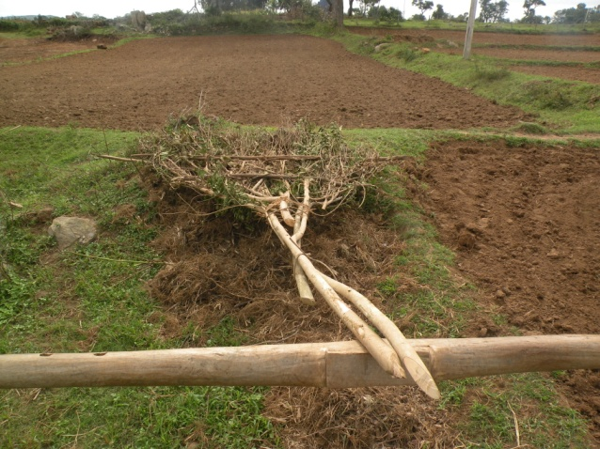

Training bullocks for traditional grain thrashing
Osawathy Pooja – first harvest ceremony:
The Farmers believes that with Nature Deities grace and protection their harvest is achieved, hence before their consumption a ritual is performed locally name Osawathy Pooja with all freshly matured grains, tubers, greens and vegetables. The sale of harvest or self consumption begins after this ceremony.
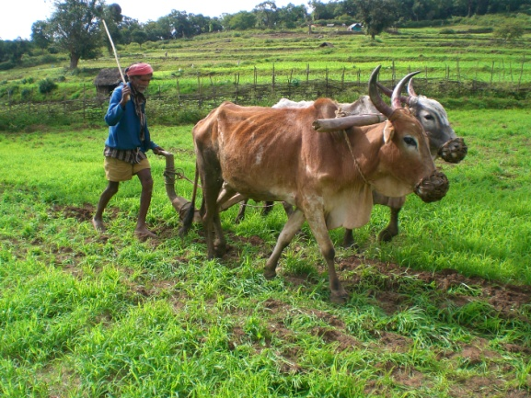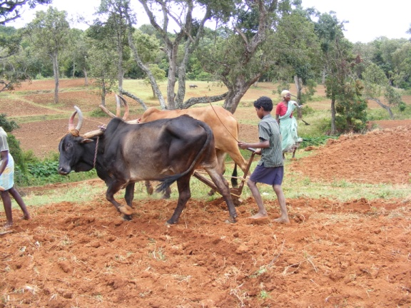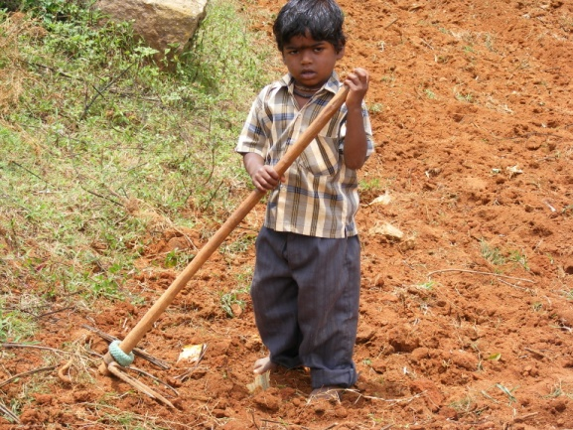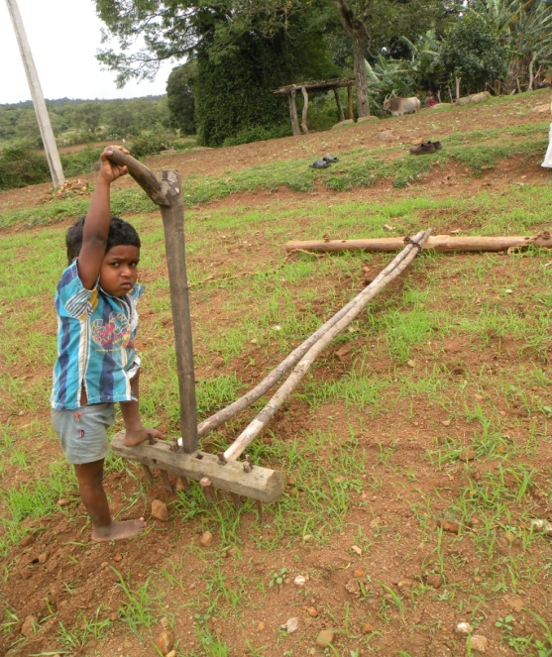
Keeping the traditional on
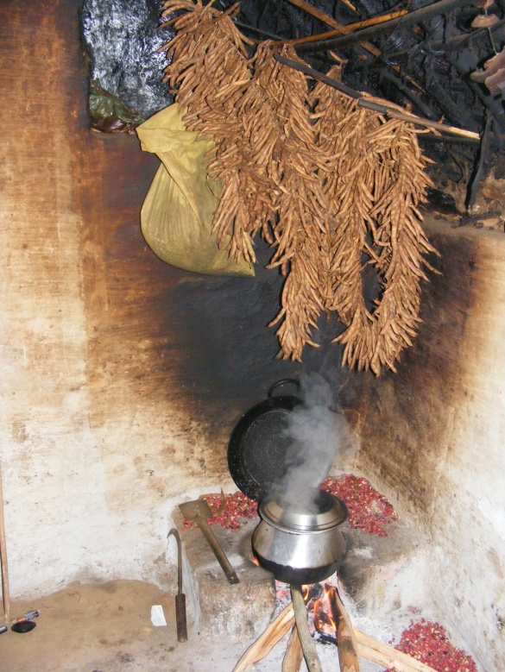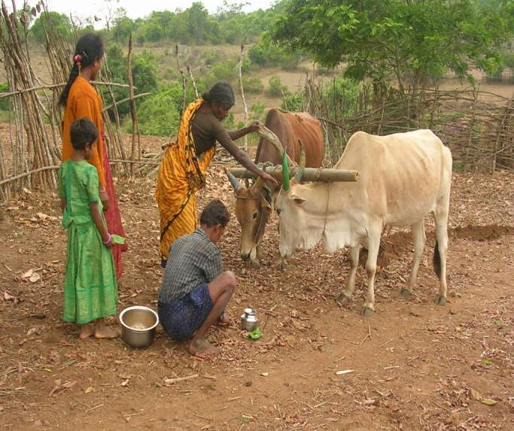
Traditional seed store above cooking place the plough is worshiped before field ploughing

The future:
The rituals and participation of youth into this traditional cultivation is gradually increasing, it assures food & Nutrition security. At the same time it is saleable item-income venue. This diverse millet farming promotes agro diversity in the region. The value addition to millet grain is a tool to scale up consumption and become essential ingredients to cookies and confectioneries. The future promises that the farmers with fair trade principles, organic principles strengthen its future amongst the community especially younger generation.

