Heavy rain triggers landslips in Ooty, Coonoor

tnn | Updated: Sep 12, 2017, 01:26 IST

Udhagamandalam: Heavy rain lashed the Nilgiri hills, especially [Coonoor](http://timesofindia.indiatimes.com/topic/Coonoor) and its surroundings, on Sunday night causing havoc. A road level bridge under construction near Marapalam on the Coonoor-Mettupalayam road was washed away partially due to the rains. Several landslips, though not major, occurred across Coonoor and Ooty taluks.  
  
Nilgiris collector J Innocent Divya declared a holiday for schools in Coonoor taluk on Monday.  
  
While Coonoor received 90.5 mm of rain, the highest in the district, for 24 hours ending 8 am on Monday, Ketti registered 39 mm. Ooty got 25.1 mm of rain. Burliar and Kotagiri registered 60 and 22 mm.  
  
According to Geetha Priya, revenue divisional officer (Coonoor division), several landslips near residential areas were reported in Coonoor and Ooty divisions. "Mud was being cleared in all areas. One such big mud slip near a road at Nunthalamattam near Ooty was also cleared quickly for traffic," Geetha Priya told TOI.  
  
However, heavy damage to a road level bridge which was under construction near Marapalam caused a road block. The Coonoor-Mettupalayam road was closed for traffic for over 6 hours till 10am. Traffic was diverted through the Mettupalayam-Kotagiri road.  
  
Following the initiative taken by the collector, the highways department pitched in to mend the road, though temporarily. By 10 am, the road was opened for vehicles going downhill from Coonoor.

"By 3pm two-way traffic resumed on the Coonoor-Mettupalayam road," said Geetha Priya.

However, according to highways officials, the repair work is temporary. If rain persists on Monday night the Coonoor-Mettupalayam road will have to be closed as a precautionary measure.

**LATEST COMMENT**

*These landslides were bound to happen due to this heavy rains.****Evans Chris Sumitra***

As the NMR track between Coonoor and Kallar saw a few landslips, the mountain train connecting the Nilgiri Express was delayed by more than an hour to reach Ooty. A set of services of the mountain train between Ooty and Coonoor and vice-versa was also cancelled as a major landslip occurred near Wellington.

A monsoon preparedness meeting headed by Nilgiris collector was held on September 5. According to the district administration, disaster management is in place to tackle any unforeseen situation.

**Landslips, tree falls disrupt traffic in the Nilgiris**

[http://www.thehindu.com/static/theme/default/base/img/author-deafault.pngSTAFF REPORTER](http://www.thehindu.com/todays-paper/tp-national/tp-tamilnadu/landslips-tree-falls-disrupt-traffic-in-the-nilgiris/article19668731.ece)

UDHAGAMANDALAM,SEPTEMBER 12, 2017 00:00 IST

UPDATED: SEPTEMBER 12, 2017 04:08 IST

SHARE ARTICLE

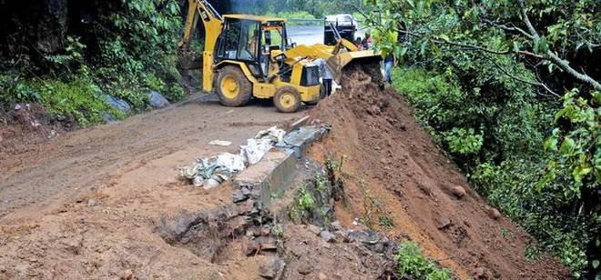

Due to mud slide at Marapallam, the Coonoor-Mettupalayam National Highway was closed on Monday.M.SathyamoorthyM_Sathyamoorthy;M_Sathyamoorthy -

Heavy downpour that hit most parts of the Nilgiris led to traffic disruptions and delay in the arrival of the Nilgiri Mountain Railway (NMR) to Udhagamandalam by more than an hour.

A total of 398 mm of rainfall was recorded in the district on Sunday and early Monday morning, with Coonoor receiving around 90 mm.

The downpour led to six minor landslips along the National Highways, while the road to Coonoor from Mettupalayam became impassible for a few hours after soil washed onto the road near Marapallam.

Trees were also uprooted due to the heavy winds in two places near Nondimedu and near Burliar, further causing delay. Traffic was rerouted to Kotagiri for a few hours. A team of 35 contract workers working for the National Highways Authority of India, overseen by S. Kulanthairaj, Assistant Divisional Engineer, Udhagamandalam, and Dinesh Kumar, Assistant Engineer, Mettupalayam and (in-charge) of Coonoor division, managed to clear the road blocks and restored the traffic flow before noon on Monday. Traffic to Manjoor was also affected after another landslip near Nunthala village.

Sources in the Southern Railways said that the rain led to a minor landslip near Wellington station, while there were tree falls reported between Aravankadu and Ketti. The two incidents led to trains, especially the morning train being delayed by more than two hours. The afternoon and evening trains also reported delay of more than an hour.

There were no reported road blockages in Gudalur as the rain there was of low intensity. Tourists returning to Coimbatore and other parts of Tamil Nadu after the weekend were especially affected by the rain and the subsequent delay in traffic.